School Desegregation in Philadelphia, PA, US
How did the School District of Philadelphia try to desegregate schools?
How did Philadelphia, and Northeast High School (NEHS) in particular, respond to desegregation?
Room 141, 7th period U.S. History, Northeast HS, Philadelphia, PA, US 19111
Created 2003-2004 academic year
Northeast High School in the early 1960s at Cottman and Algon Ave. in Northeast Phila.
NEHS 1909 at 8th and Lehigh Ave. in North Philadelphia/Kensington

Please check out these pages!

**Interviews with 5 teachers who remember NEHS in the 1970s and articles from the school paper

**Articles from Philadelphia papers on schools
1950s - 1990s

Demographic Data

Time line and analysis
based on research of newspaper articles from Temple University's Urban Archives, and class presentations by
Dr. Anne Phillips and Mr. Michael Hardiman, Esq.

Students who worked on the section:
Information from Dr. Anne Phillips: Nellie Sanchez and Tanesha Lewis
Information from Mr. Hardiman: Abdeel Bhatti and Wen Feng Chen
Analysis of all information: Abdeel Bhatti, Malik Bostic-Smith, Wen Feng Chen, Jose Colon, Kevin DeJoie, Tanesha Lewis, Kareem McCafferty, Sean McGregor, Rafael Nako, Nellie Sanchez, Alex Stokes, Heather Volent, Jerrell Walden
--------------------------------------------------------------------
Summary and Analysis of Information
The School District of Philadelphia "dragged its feet" and is still under court order regarding desegregation. After the Brown v. Board of Education case in 1954, public schools throughout the U.S. had to end racial segregation. In 1956, the governor of Pennsylvania ordered a statewide survey of desegregation in public schools of staff and students. (Philadelphia had discriminatory policies regarding African American teachers and administrators.) In 1957, the governor said state funds would be cut if schools didn't end enforced racial segregation. This threat didn't change the reality of school segregation in Philadelphia. Faculties and student bodies continued to be segregated because of segregated housing and school geographic boundaries . At time the School Board intentionally designed school boundaries that furthered segregation.
From the 1960s - 1970s, there was vocal opposition to school integration in Philadelphia. Mayor Tate and City Council President D'Ortona opposed desegregation and spoke out against busing. At a Northeast Town Meeting on Quality Education and Integration (1964) (see the summary below) some people questioned the need for integration and opposed busing while others wanted their children "to see Negroes (as teachers) in a capacity which brings respect." Attendees also questioned the academic motivation and skills of African American students. It seems adults assumed African American students were academically inferior to white students. The adults also seemed to think giving African Americans a better education would take away from the white students. There were also some parents who feared "too much inter-mingling and a possible aftermath - intermarriage." In the Northeast in the late 1960s, there was busing to Spruance and Carnell elementary schools. There weren't "riots" but there was vocal opposition from the local community (Oxford Circle) and parents assumed the African American students would academically hinder their children. There were also stereotypes regarding "white flight" and African Americans moving into the neighborhood.
Northeast High School was in the news because a group of students from the Northwest part of the city were attending Northeast without transfers. In 1968, Northeast only had 30 African American students out of a student body of over 4000. At the same time, there was an effort to have students from Northeast get to know students from West Philadelphia High School. They had classroom exchanges and a retreat.
In the 1970s, the school district was under court order to integrate schools but it failed. From the Mayors office to the School Board, no one wanted forced busing to integrated schools. The voluntary busing led to African American students being bused but not white students. The School Board established magnet programs and magnet schools to foster integration. In 1979, the Federal Office of Civil Rights charge the School District with violating civil rights laws by allowing white students to transfer out of predominantly black schools in their neighborhoods. This happened in Olney, Oak Lane, Logan, Hunting Park, Kensington, and Port Richmond. A 1979 Supreme Court decision found that all cities had to desegregated schools - "the decision (as) potentially important to northern school districts as the high court's 1954 opinion banning separate segregated school systems was to southern districts." (7/3/79 - see article under 1970s) 25 years after Brown v. Board Philadelphia was still trying to avoid school desegregation. Even though the School District only had a voluntary desegregation plan (versus forced busing) there was vocal opposition. There were protests from parents who did not want their children attending Kensington and Edison High Schools. Local politicians, including Rep. Borski, Councilman Rafferty, and City Commission Chairman Margaret Tartaglione joined and encouraged the protesters. Local TV stations refused to air voluntary desegregation advertisements created by the School Board because the ads were "controversial." There was a forced teacher desegregation plan in 1978 that was upheld by the federal courts in 1984. There was a sharp increase in African American teachers at Northeast High School in the late 1970s because of this plan.
In 1980, the School Board had a $100,000 public relations campaign to promote voluntary desegregation. There were only 8,000 out of 220,000 students who had transferred into special interest magnet schools. Throughout the 1980s the Pennsylvania Human Relations Commission took the School District to court over desegregation. The School Board wouldn't budge on mandatory busing. There were more voluntary busing plans. Northeast, Frankford, Olney and Kensington High Schools were targeted for voluntary transfers. If there was a forced busing plan, Northeast High School students would have been bused to Olney High and Lincoln High School students to Gratz High School. As late as 1988, the School District's voluntary school desegregation plan was considered inadequate by the PA Human Relations Commission. By the late 1980s, Philadelphia's demographics, especially school demographics had changed; nearly two thirds of the School District's students were African American.
The School District has been working on issues of fairness and school desegregation for about 45 years. There were many court battles and some protests. The entire process took too long. In the 1950s, the School Board should have "jumped into it" and said "this is the way it's going to be." Instead, they either took baby steps or publicly opposed desegregation. Philadelphia was no different than any other area of the U.S. If Philadelphia had forced busing, there would have been more protests just like in Boston
----------------------------------------------------------------------
Timeline

Philadelphia schools were desegregated by law in 1881. Before 1881, there were four schools for African American students. The schools were located in South Philadelphia near 6th and Lombard Streets. Northeast High School (not Central High School) was the first public high school to admit African American students. Philadelphia continued to discriminate against African American teachers. (African American couldn't teach high school or become principals).
In the 1950s, there was "de facto" segregation based on neighborhood demographics. The Pennsylvania Human Relations Commission in 1969 took the School District of Philadelphia to court to end "defacto" segregation. It took ten years to begin to implement a voluntary desegregation program in Philadelphia. (Harry Silcox, speaking to our class on May 13, 2003) .
-------------------------------------------------------------

Key dates in Philadelphia's school desegregation in the 1950s - 1960s (from list presented by Dr. Phillips)
--1953: Example of the School Board of Philadelphia maintaining racial segregation in schools
Day School is built in Northwest Philadelphia. Emlen School in 1952 was 64.4% African American and in 1955 was
86.1% African American. The boundary lines for Day School were drawn to further segregated Emlen School while
Day School became a "white" school. The School Board could have drawn the boundary lines by a road which would have integrated the schools. Instead, it used a railroad track which created two segregated schools in adjacent neighborhoods.
--May 17, 1954: Brown v. the Board of Education of Topeka, KS was passed by the United States Supreme Court. The Court concluded "separate is inherently unequal."
--1955: "Implementation Decision" (Brown II), schools were told to desegregated "with all deliberate speed."
--1957: Civil Rights Act was passed the Commission on Civil Rights was created
--1957: One of the best known school desegregation fights began in Little Rock, Arkansas in 1957
--June 7, 1961: Chisholm v. Board of Public Education was a school desegregation suit filed in federal court against the School District of Philadelphia (Leon Higginbotham was the head of the NAACP and the chief attorney in the case)
--1963: Judge Wood insists the School District of Philadelphia submit a desegregation plan
Congress on Racial Equality (CORE) led sit-ins at Philadelphia City Hall demanding the hiring of African Americans on public construction jobs.
Philadelphia NAACP led by Cecil B. Moore held mass demonstrations at the Strawberry Mansion School construction site.
Coordinating Council for School Integration was formed by community organizations to work to have local schools desegregated. (The organization was chaired by Sylvia Meek. It ended in 1968).
In Philadelphia, Four Hundred Ministers threatened direct action. As a result, the Educational Improvement Program was implemented in grades 1 - 3 in about 60 schools. The program ended after 3 years when funding was cut.
--1964: Philadelphia' School Board announced it was going to bus students to relieve overcrowding. There were protests.
The students from the overcrowded schools were African American, and they were being bused to predominantly European American school. The protesters organized a group called the Parents and Taxpayers Association in 1964.
Mayor Tate and City Council President D'Ortona encouraged the European American opposition by speaking out against busing. D'Ortona campaigned throughout the city against busing.
August 28, 1964: 3 days of riots began in Philadelphia on Columbia Ave. (today Cecil B. Moore Ave.)
--1965: Elementary and Secondary Education Act passed. School districts found to be in violation of federal law would not receive monies under the act.
In the summer, picketing around Girard College (a private, residential, free school for "orphaned white boys" funded by an endowment from Stephen Girard) was the symbolic focus for the school desegregation movement in Philadelphia.
--1967: Police Commissioner Rizzo led an attack on African American students who were demonstrating for "Black
Studies" in the Philadelphia public schools. (Rizzo was elected mayor in 1968 and 1972.)
--1968: School desegregation in Philadelphia shifts to the state under the Pennsylvania Human Relations Commission.
------------------------------------------------------

Mr. Michael Hardiman, Esq. worked with the Pennsylvania Human Relations Commission.

The Commission was formed in 1955 as the Pennsylvania Fair Employment Practice Commission. In 1961 it began to include problems with discrimination. In 1968 the Commission told the School Board of Philadelphia to desegregated the schools. In 1970, when the School Board did not submit the desegregation plan, the Commission filed a law suit against the School District. The Court declared the School District of Philadelphia "unlawfully segregated." The School District appealed the decision in 1972 and the Court again told the School District to desegregated. From that point, the Commission worked with the School District to desegregated the schools. As of 2003, the case is still open and many schools are still segregated.
Chronology of Interaction Between the School District and
The Pennsylvania Human Relations Commission Desegregation Plan and Funding Fact Sheet (from Temple Urban Archives files) (February 1968 - November 14, 1973)
1. 2/68: The PA Human Relations Committee mandated the Phila. School District prepare a plan to desegregate the Phila. public schools.
2. 6/68: School District requested and was granted a 90 day extension on submitting a plan
3. 9/68: School District's plan includes a once a week opportunity for elementary students from uniracial black and white school to get together
4. 10/68: Overwhelming negative community reaction at School Board meeting primarily from white community
5. 11/68: After 37 cluster meetings, "strong conclusion was expressed that educational excellence must take priority over the physical mixing of students in cases where both can't be achieved together"
6. 12/68: School District ask PA Human Relations Commission for financial help
7. 5/69: Extensive plan submitted outlining School District's best intentions in the light of the hearings '"feasibility of which will have to be determined by Federal and State governments willingness to pay for them by the willingness of the people of Philadelphia to accept them"
8. 7/69: PA Human Relations Commission called Philadelphia's plan unsatisfactory for lack of information
9. 11/69: More information sent to PA Human Relations Commission
10. 11 - 12 / 70: Series of meetings with the PA Human Relations Commission staff and School District staff where PHRC staff shared their suggestions on 16 ways the School District could move to achieve greater physical desegregation
11. 12 / 70 - 1/ 71: School District asks Council of Greater City Schools for more money for desegregation
12. 6/71: Final Order and Findings of Fact from the PA Human Relations Commission to the Philadelphia School District (on desegregation plan)
13. 8/71: Initial steps were taken by the Office of Community Affairs for the submission of a desegregation plan for consideration by the Superintendentand School Board as a response to : (1) State Human Relations Commission Order to desegregate, and (2) making application for a grant under the Emergency School Assistance Program
14. 8/72: Commonwealth Court of Philadelphia consolidated cases of Philadelphia and 4 other school districts and ordered them to submit a minimum acceptable plan to the PA Human Relations Commission
15. 9/72: PA Human Relations Commission handed down an amended Final Order to submit a desegregation plan by January 1973 (Philadelphia Board of Education requested two extensions)
16. 9/73: Philadelphia Human Relations commission agreed to cooperate with the School District in preparation for desegregation plan. Board member Mr. Augustus Baster is Desegregation Chairman.
17. 10/73: Community Desegregation Task Force established in help of preparation of desegregation plan
18. 11/73: Judge Wilkinson, Jr. orders School District to submit a plan for school desegregation by February 15, 1974

Students who worked on the historical inquiry project:
Saleem Anderson, Abdeel Bhatti, Malik Bostic-Smith, Wen Chen, Victoria Collins, Jose Colon, Kevin DeJoie, Sean Dinkelacker, Heather Florian, Narissa Knorr, Tanesha Lewis, Kareem McCafferty, Sean McGregor, Lauren McQuaid, Rafael Nako, Nicole Rubinson, Nellie Sanchez, Alexander Stokes, Erica Vanhinkle, Heather Volent, Jerrell Walden
Teacher: Donna Sharer
Many people made this project possible:
Guest speakers Dr. Anne Philipps and Mr. Michael Hardiman
Teachers who agreed to be interviewed:
Mrs. Davis, Mrs. Harrell, Mr. Hecht Ms. Pavalko, and Mr. Swaby
Teachers who administered the surveys in their U.S. History class: Ms. LeBrum, Mr. Lynch, Ms. Cohen, Ms.
U.S. History class students who took the surveys
Photocopying help for the surveys from Ms. Bower
Time in the Northeast High School library to use old Megaphones and yearbooks from Mr. Bell (and for the photo of Northeast High School from the library web page)
Copies of old Megaphones from Mr. Weismann Temple University Urban Archives and Ms. Margaret Jerrido for inviting us to use the archive, for "pulling" files, and photocopying articles

WDAS Radio Discussion of Integration in the Philadelphia Public Schools
with Joseph H. Rainey as Moderator and Dr. Allen H. Wetter, Superintendent of the School District of Philadelphia and Floyd L. Logan, President of the Educational Equality League (Wednesday, June 22, 1960 at 11:30 pm)
Summary of the Education Equality League's Floyd L. Logan's presentation
1. The Education Equality League estimated that Philadelphia had 247 public schools, 19 were all African American. Of the 58 principals, 55 were white. There was a steady increase in all and predominantly white and African American schools.
2. The Education Equality League was certain that actual segregation of pupils stemmed from segregated housing, a system of districting (schools), and low educational standards in schools in underprivileged areas. In 1958, there were no wards in Philadelphia without a "minimum of Negro residents." Because of the increase in the African American population in Philadelphia and community agencies working for housing integration, "there are greater opportunities than ever before for enforcement of Pennsylvania's law for interracial pupil integration, and planned integration in non-fringe areas through an intensified educational program."
3. One major goal was "to bring the races together in the classrooms of the public schools during their most impressionable period (childhood), where they will acquire a better understanding of one another, which will inevitably result in more interracial goodwill and a greater willingness to learn to live together in an inter-mixed society."
4. "Culturally handicapped slow learners in the Philadelphia public schools number approximately 80,000 or 33% of the approximate pupil enrollment of 240,000... Most of these slow learners are environmentally handicapped Negro pupils who are concentrated in public schools in underprivileged areas.... these schools are classified as minus which is obvious to the extent that both white and Negro parents shy away from sending their children to them. Because of the concentration of so many environmentally and culturally handicapped pupils, most of whom are Negro, most white teachers and a few Negro teachers object to teaching in such schools. Consequently a disproportionately large number of inexperienced and in many instances undedicated substitute teachers are assigned to teach in these schools... more money should be provided for improving the educational status of such schools in underprivileged areas through a general dispersal of many of their pupils to other schools through formation of remedial classes, reduction of class sizes, an increased supply of free textbooks, and the voluntary and compulsory assignment of some of our most able and dedicated teachers to teach in them.
5. ...although Philadelphia has commendable increased its total number of Negro teachers to more than 2,000, that most of these teachers are assigned to all and predominantly Negro schools, and that most of them have been by-passed for promotion in spite of merit, with few exceptions, for many years. Also, there are still approximately 135 schools in Philadelphia which do not have any Negro teachers. ... teachers should be willing to render higher and more dedicated service through a willingness to teach where they are needed, as they should be required by law.
6. Pennsylvania's public schools integration laws do not favor gradual enforcement of school integration. Integration is to be an "immediate effect."
---------------------------------------------------------------------------------------------------------------------

Northeast Town Meeting on Quality Education and Integration Neighborhood Center, May 7, 1964
Discussion Group Summary
-----------------------------------------------------------------------------------------------------------------------------------
Integration and Quality Education
1. discussion of the relationship of quality education to integration and concerns over the goals of education, problems of inter group relations, techniques of school integration and ways "minority groups" traditionally "moved upward" in the United States
2. some groups felt integration is part of a basic good education while others didn't want to sacrifice quality for integration
3. "One group asked whether increasing the value of a Negro's education takes away from the white's or does it give more people a better chance? Also, if all the schools are equal, do you still need integration?"
4. "There was strong commitment to the individual's right to move where he wants ...people move where they can afford to, but it was noted there are residential ghettoes through the area, either through choice or availability and not everyone can move where they want. Thus, de facto and de jure segregation are not alike, and not only is the Negro 'deprived.''"
5. "Many worried about the schools' responsibility - is it to give children skills and information, or to help them become better citizens?... the child's world of the future will be different and that he should have contact with different kids of people for 2 reasons: one, to prepare for the cultural exchanges and multi-racial world of higher education, and two, to give children more understanding.... there should be Negro faculty here so children can see Negroes in a capacity which brings respect."
6. "There was considerable worry about mixing children with different goals, backgrounds, interests, and economic levels. The motivation of Negroes was questioned, and a 10% high school graduation figure cited as support to the idea of low Negro achievement. Also bad experiences in places like Strawberry Mansion were recounted. There is a real fear about losing out if schools are integrated, especially if the youngsters come from schools now receiving the kind of inferior education discussed. Some questioned how other groups rose above poverty, suggested Negroes could, too, by studying and helping themselves. There was concern about too much inter-mingling and a possible aftermath - intermarriage."
7. "There was general support of the neighborhood school and for bringing up standards in segregated schools, some coming out for 'separate but equal' facilities. The main disadvantage was seen as not providing contact for people of different backgrounds."
-----------------------------------------------------------------------------------------------------------------------------------
Northeast follow-up Town Meeting May 20, 1964
Neighborhood Center (Mrs. Berkowtiz, Coordinator)
A meeting was held with a speaker (Dr. Dan Dodson) and group discussion. It was followed by meetings with small group discussions in the Fall of 1964.
1. Group wanted to form a Northeast School Committee to work on integration and other school issues. They agreed to follow through on the Town Meeting and invited other groups.
2. Observations the groups wanted to share with the Philadelphia Board of Education:
--a large part of the confusion over busing "has stemmed from rumor and incorrect information"
--"there is a need for more and correct information and a clear definition of goals by the School Board"
--"there is great interest in having Negro faculty members in the (Northeast) schools" - faculty "are not as feared as pupils coming in would be and would also enable the community to meet Negroes on this professional level"
--"more contact between children from different schools - some kind of real interchange"
--boundary changes were recommended "where they were most feasible"
--"reverse" busing was generally rejected, some objecting to any busing or to busing children long distances or moving those who are very young
--"it was suggested if there is to be busing for integration, it be begun early, before there are prejudices and too many differences in learning levels"
--"others felt (integration) could not be forced, that is integration is going to come, 'let it come by itself' and that the biggest challenge to this community is over-crowded schools"
--"considerable worry was expressed about allocations to money to implement integrationplans"
--"There were questions raised about the competency of Negro teachers: are they trained and certified the same as white teachers?"
--"In curricular areas, it was suggested that human relations be part of studies; that situations be provided for experiences with other groups... and that we divorce ourselves from false values and snobbery by not insisting on reassurances that sending schools will only send high I.Q. children to receiving schools."
--"since change is inevitable, parents must be educated"
--"some felt meetings help ventilate feelings and bring about more understanding, other resent 'outsiders coming in and saying Negroes are moving in.' The public is swayed by rumor in these situations, so education and correct information are necessary."

Interviews with 5
Northeast HS Teachers (2003)
Articles from the NEHS Megaphone

Northeast High School in 1976
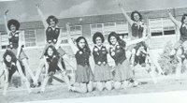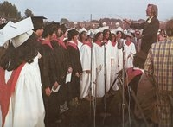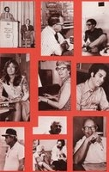

---------------------------------------------------------------------------------
Another image... March 1976

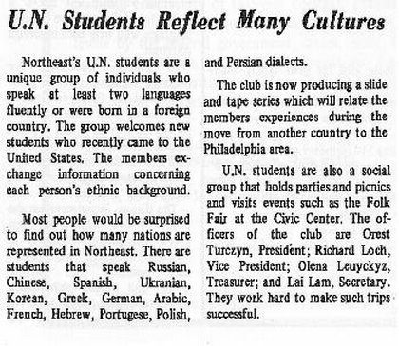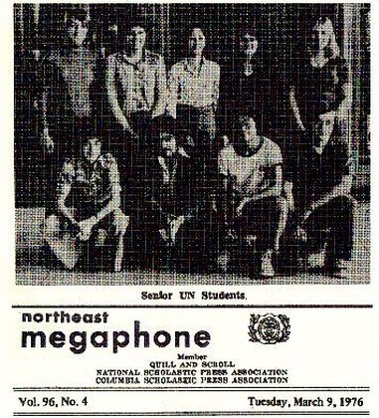

But, by April 1976

We don't know when an annual African American cultural assembly began but the 1976 event was the most controversial. Though there isn't controversy described during the 1983 event, the photo (see below) "is worth a 1000 words." The articles list what was included in each assembly and quotes some participants as well as the staff sponsor. We don't know if other cultural groups had assemblies.
Ms. Harrell and Ms. Pavalko (see below) told us about this "riot." They told us the origins of the "riot" were disputed. They said some people blamed it on relationship fights. They also told us the Philadelphia Mounted Police surrounded the school. They thought there was too much police response.
The article states it was reported the controversy was in response to a speech and the Black National Anthem. The Black Culture Society disagreed. They blamed it on "prejudiced attitudes of some whites in Northeast."

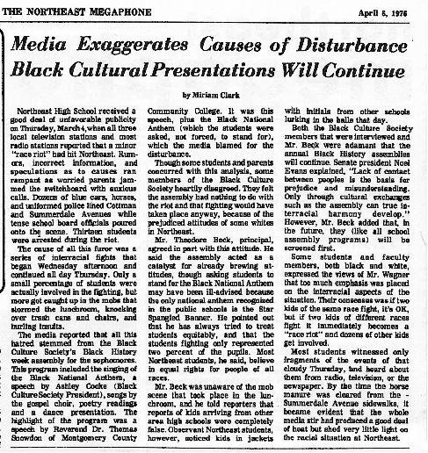

December 1978
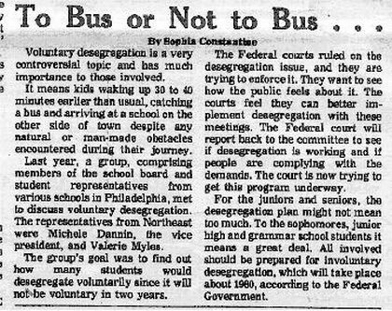
The 1978 article states involuntary desegregation will occur in 1980. This NEVER happened in Philadelphia. We found there was always institutional resistance to involuntary desegregation.

Magnet programs were established in schools to increase desegregation. Northeast's magnet program was founded in 1962-1963 as SPARC (space/science program with funding post Sputnik.) It was apparently expanded in 1978.

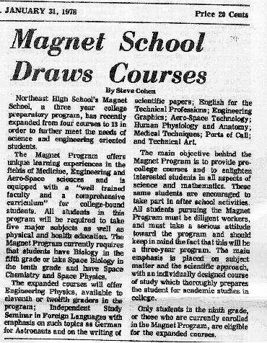

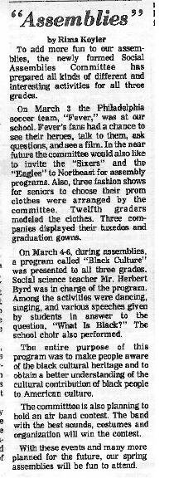March 14, 1981

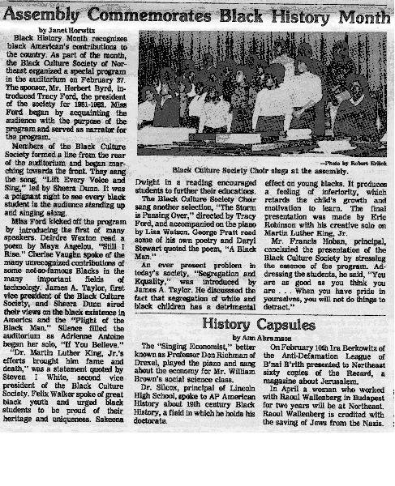March 11, 1982

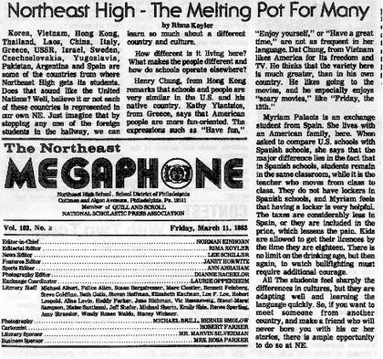

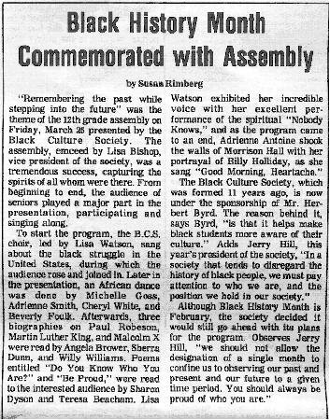June 3, 1983

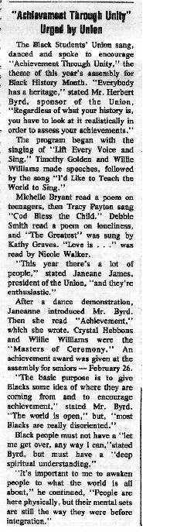March14, 1985

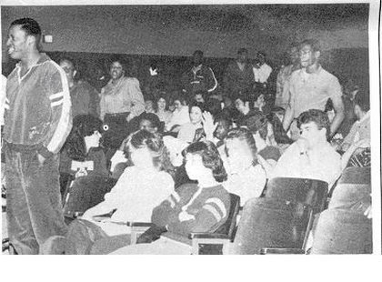
Photo from "Black History Month" Assembly held March 25, 1983
(see article June 3, 1983)
Students were asked to stand for the Black National Anthem.
According to the caption, "everyone stood." Obviously, based on the photo, most white students, and a few African American students, did not stand.

June 7, 1977
We were told by Ms. Harrell and Ms. Pavalko this was a controversial election. Mr. Caston was first denied his victory. It is interesting there is nothing about the controversy and the picture appears on page 2 (out of 4) versus the front page. There was no article to accompany the photo and caption.

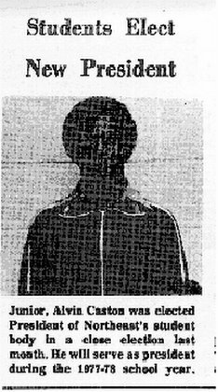

December 20, 1978
The article includes the variety of activities sponsored by the Black Cultural Society. In the late 1970s, Northeast also had Hebrew and Korean Cultural Societies. We didn't find any articles on other cultural groups.

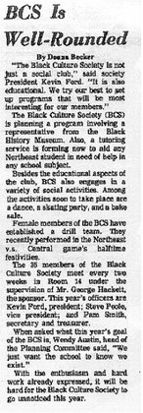

In 1982 article states a school must be "40% black and 25% white to be considered desegregated." The article claimed Northeast qualifies. In 2002-2003, Northeast still does not qualify if the percentages are correct.

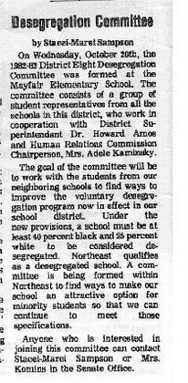
Nov. 24, 1982

Five Current (2003) teachers who have taught at Northeast High School since the mid to late 1970s agreed to meet with us and share their memories. Many of the teachers addressed the School District of Philadelphia's "racial balance" policy for teachers which began in the mid/late 1970s. Specifically, we asked them:
1. How long have you taught at Northeast HS? Why did you stay at Northeast High School (NEHS)?
2. How has NEHS change din the last 25 years? (school hours, demographics of staff and students, security, extra curricular activities, academics, fashion, student behavior)
3. How did the NEHS community respond to the desegregation policy of the School District of Philadelphia? How did the NEHS community respond to the influx of immigrants?
4. What images / special memories do you have of the NEHS staff and students 20 - 25 years ago? What was NEHS's reputation? Do you remember any racial incidents?
5. Were clubs, sports, classes and the cafeteria segregagted? Did students interact with students of other ethnicities? Were classes tracked? Was the magnet program integrated?
6. What else do we need to know to understand and appreciate the School District's desegregation policy 20 - 25 years ago? What else do we need to understand or appreciate about NEHS?

---------------------------------------------------
Ms. Harrell
Summary by Jose Colon and Devin DeJoie
Ms. Harrell, a math teacher, has been at Northeast High School since 1975. She was "forced" here because of the School District's desegregation policy for staff; Northeast needed more African American teachers. When she first came to Northeast, parents would give orders but once parents understood she helped the students, parents help her with things like painting her classroom. She has stayed at NEHS because she things she can help people.
When she first came to Northeast, it was like a large family with about 2300 - 2500 students. There was one female NTA on the 2nd floor and there weren't fights. There were no school police. Students remembered late and absent notes. Students were well dressed; they had style. A lot of students went to college and received grants and scholarships. When students graduated, the alumni helped.
Northeast's magnet program was the first special program. There were some minority students because they were told they had to include minority students. Students had to work hard to stay in the program. The School District brought in "charters" and she was picked for the Liberal Arts Charter. It took a lot of work to make it work, including working on weekends, but teachers didn't mind.
There was racial tension and conflicts at Northeast. In 1976, there was an incident when the police came on horseback and surrounded the school. There was a Black History Month assembly in February. Supposedly, in the assembly, some white students refused to stand for the Black National Anthem. Some people said it was a black/white fight.
There was also an African American science teacher who wanted to start a Black student group. The principal didn't want the club but the teacher could organize a Black History Month program. The program was scheduled for a Friday and on the Thursday after school before the program, the principal canceled the program. The teacher went ahead with it because the students had prepared and it was too late to cancel. The principal called in police and three police walked on stage during the program. They told the teacher if he didn't leave, he would be arrested. The principal said "this is my school." Both Black and white teachers were upset. The principal transferred the teacher out of Northeast HS.
As part of the School District voluntary desegregation program, many students were bused to Northeast. There were also some problems in the community because students were bused. Some people in the community near the school were not accustom to seeing African Americans at certain times of the day. African American students couldn't play at Jardel playground after school. (Jardel is a Philadelphia Recreation Center 2 blocks from the school.)
There was also discrimination from some staff towards African American teachers. Some assumed I went to a poor school and lived in a poor neighborhood. One person knew I had two degrees and wouldn't talk to me. I was the only woman in the math department for two years. At meetings I was todl to take minutes. I was aksed where I went to college. One teacher stood outside my door and listedn to me teach. He told me "go back to college and go to a good college this time." "Go back to school to learn math. I go by your room all the time and listen to you." I then spoke with him and his attitude changed.
It is important to appreciate that people paved the way for you to be at Northeast HS. We can walk the halls without looking left and right. Teachers and students need to work together.
----------------------------------------------------
Ms. Pavalko
Summary by Malik Bostic-Smith and Alex Stokes
Ms. Pavalko has taught in four Philadelphia schools. most of her time has been at Northeast. She is a Family and consumer Science teacher and runs the child care lab. She taught at Olney, Northeast, Gratz and West Philly high schools. She came to northeast in 1975 but had to leave in 1979 because Northeast had too many white teachers. She returned in 1984. The School District had a staff desegregation policy and Northeast had too many white teachers. The School District couldn't encourage students to integrate schools but could force the staff to integrate.
Ms. Pavalko said Northeast had a detention room (141) and two people, one man and one woman, in the Dean's Office. There were two security officers in 1975. Northeast was considered a "good school" - many students went to college. Northeast had many traditions. Black and white students did interact with each other. They sat together in class and some knew each other since kindergarden. Nevertheless, she didn't always feel accepted because some male teachers were sexist. One told her "you're not so hot."
She remembers a race riot in 1975. Police on horseback surrounded the school in 1976. There was disagreement over what started the fight. Some people said it was because white students refused to stand during the Black National Anthem during a Black History Month Assembly. She thought the police response was overblown.
Northeast also had a lot of gang fights. The fights were "white" on "white" neighborhood versus neighborhood fights. Students identified with the street they lived on and they formed gangs.
Northeast students used to "dress to kill" - fashion was important. Students didn't wear sloppy or ripped clothing. Today students dress is more casual.
----------------------------------------------------
Mr. Hecht
Summary by Victoria Collins
Mr. Hecht has been a teacher at Northeast High School since September 1975. He was one of the white teachers that was able to stay. He has stayed because he has great luck with students. Northeast has changed a lot since 1975. It used to have 3 grades (10 - 12) and 1134 students graduated in 1978. In 1975, 80 - 90% of the students were Jewish and maybe 1% were African American. There were a couple Hispanic and Asian students. Today there are students from over 47 countries.
Northeast had an "incredible" reputation. Students were into achievement and were very competitive. Northeast had Merit Scholarship finalist and semi-finalist. The school was academically more difficult. Teachers expected more from students and students did assignments. Today the students are less competitive. We will have students doing well - more AP History student passed last year than since 1990. Nevertheless, we can't mistake competitiveness for accomplishment. There are many accomplishments today.
There was no real security in the school until about 1990. Teachers and students got along better. Students were more respectful and didn't challenge teachers. Students were on time. Everyone dressed more formally because it was a School District rule. Chewing gum was a serious offense. There were also more clubs like gymnastics and bowling.
He doesn't remember anything negative in response to the School District's desegregation policy. There was an influx of immigrants and NEHS was accepting of new students. There may have been some negative reactions from some faculty when more African American students came. there was one Vice Principal who was a bigot. he said there may have been 1 - 2 racial incidents. Today there are more fights because the school is crowded.
Students may segregate themselves in the cafeteria but students cross racial lines. The Yearbook has African American, Asian, and white students who work well together and hang out together. Clubs and sports have always been integrated.
Classes used to be tracked (separated by academic ability). The differences in classes today are more difficult classes are voluntary. The exception is the magnet program which was started to help integrate the school. Twenty five years ago the School District's desegregation policy was voluntary for students. Since 1976, the School District has had a policy of faculty integration. The faculty is suppose to be racially balanced.
Northeast High School is fortunate to have a strong and supportive Alumni Association. It sponsors scholarships and tirelessly works for the school. The Home and School Association is also active.
----------------------------------------------------
Mr. Swaby
Summary by Lauren McQuaid
Northeast High School ha changed in some ways over the past 25 years. Today there are many more students. 25 years agot here were perhaps about 2500 students and most were Caucasian. The behavior of the students has also changed. Students were better behaved 25 years ago. Today, teh school day is longer and there are many more school policy and aids. The reputation of the school hasn't changed too much. It has always been a good school with many college bound students.
When the school desegregation process started in teh late 1960s, tehre wasn't really a negative repsponse. The school was already in teh proces of itnegrating. The beginning of teh annex and Magnet program was in place. One purpose was to promtoe integration.
He likes the School District's voluntary desegregation plicy; parents have choices and since iti s not forced ti is a good model. Some epople might disagree, but overall it wasn't reallya probelm.
There were already some African American teachers when he arrived. There weren't many racial conflicts and if there were, they were outside of the school. There may have been problems at other schools. There may have been very few incidents in the lunchroom. There was never really segregation in clubs or sports. The cafeteria might look segregated but students just sit with their friends. The school and students integrate nicely. A few individuals may have had attitudes but they were not noticed.
----------------------------------------------------
Mrs. Wendy Davis
Summary by Sean McGregor and Nicole Robinson
Mrs. Davis was transferred to Northeast high School in 1979 because Northeast needed more African American teachers. She stayed because she liked the job and other teachers and students liked her. Before the late 1970s, Northeast was primarily a Caucasian, Jewish school. Today it is a mini metropolis with students of many different backgrounds. There is also a larger population which leads to more safety issues. There are also more behavior problems including the use of profanity.
Northeast always had a good academic reputation. Nevertheless, there were a few racial incidents. There was controversy over the election of an African American class officer.
School sports and clubs have always been integrated. Today there are more diverse groups such as the Haitian Club, IndoPak and Asian Club. The Magnet program was integrated because magnet programs were created to encourage integration.
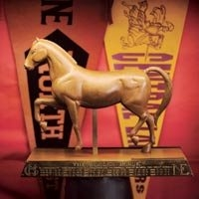
Northeast has proud traditions. The Alumni Association is very supportive. People come back each year because of the traditions like the Northeast / Central football game played every Thanksgiving.

Demographic Data:
Philadelphia and
Northeast High School
(data, graphs and analysis)

Philadelphia's population in 1950 was over 2 million. Over 70% of the population was European American (white). By 2000, Philadelphia had less than 1.5 million people and the European and African American population was almost identical. The percentage of African American, Latino/a and Asian America students in the School District steadily increased. In 1940, 20.4% of the students in Philadelphia schools were African American. By 2001, 65.3 % of the student body was African American, 4.9% Asian American, 13.1% Latino/a, and 16.4% European American.
Northeast High School began a voluntary desegregation program in 1977 - 78 for staff and students. By 1982 - 1983, nearly 30% of the student body was African American. In 2002-2003, nearly 30% of the student body is African American. Today there are more Asian American and Latino/a students than in the late 1970s. Northeast continues to have a significant number of immigrant students from all around the world.
Race/Ethnic Composition of Northeast High School
YEAR | African  American | White | Asian | Latino | Other
2008-2009 | 35.9% | 27.4% | 20.5% | 14.6% | 1.5%
2007-2008 | 35.3% | 28.8% | 19% | 15.5% | 1.4%
2006-2007 | 35.2% | 29.7% | 18.2% | 15.8% | 1.1%
2005-2006 | 33.6% | 32.9% | 17.1% | 15.3% | 1.2%
2004-2005 | 32.2% | 37.8% | 15.2% | 14.9% | N/A
2003-2004 | 30.6% | 41.1% | 14.2% | 13.9% | N/A

Changing Philadelphia Demographics  from presentation by Dr. Anne Phillips  Demographic changes in the U.S.:  During the 1950s, 1.5 million African American migrated from rural areas to urban areas  During the 1960s, 1.4 million African American migrated from rural areas to urban areas  Demographic changes in Philadelphia:  Between 1940 and 1950, 90,635 African Americans migrated to Philadelphia  Between 1950 and 1960, 64,974 African American migrated to Philadelphia  In the decade 1950 - 1960, Philadelphia's African American, Latino/a, and Asian  American population increased 41.2%; the European American population declined 13.3%  African American demographic isolation:  North and West Philadelphia became "virtually" African American  Racial change occurred quickly in Strawberry Mansion, Tioga and Southwest Philadelphia  Between 1930 - 1970, the index of African American isolation in Philadelphia rose from  27.3% - 75.6%  In the 1950s, Philadelphia's Puerto Rican community began to increase.  Demographics in Philadelphia schools:  The rapid transformation of the racial makeup of neighborhoods was matched in the schools  African American students enrollment went from 20.4% in 1940 to 47% in 1960  African Americans were the majority of students, 51%, in 1960 in elementary schools  Less than half of the European Americans students, 48%, were enrolled in public schools while 92% of African American students were enrolled in public schools | 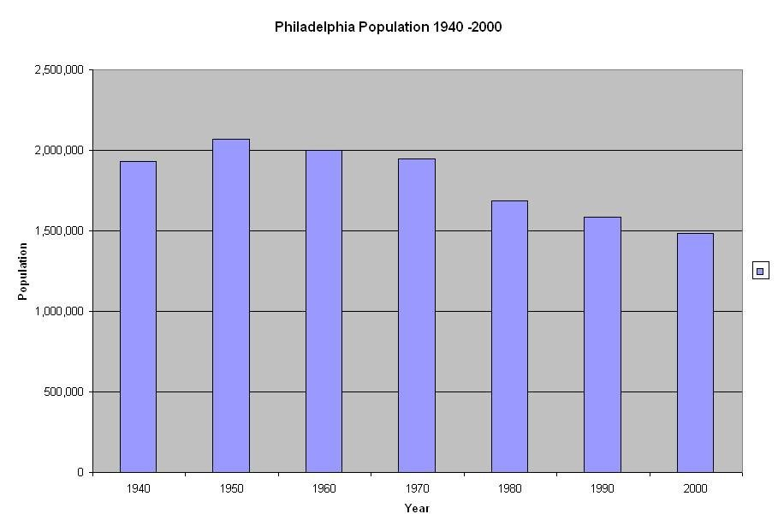Source: U.S. Census Data  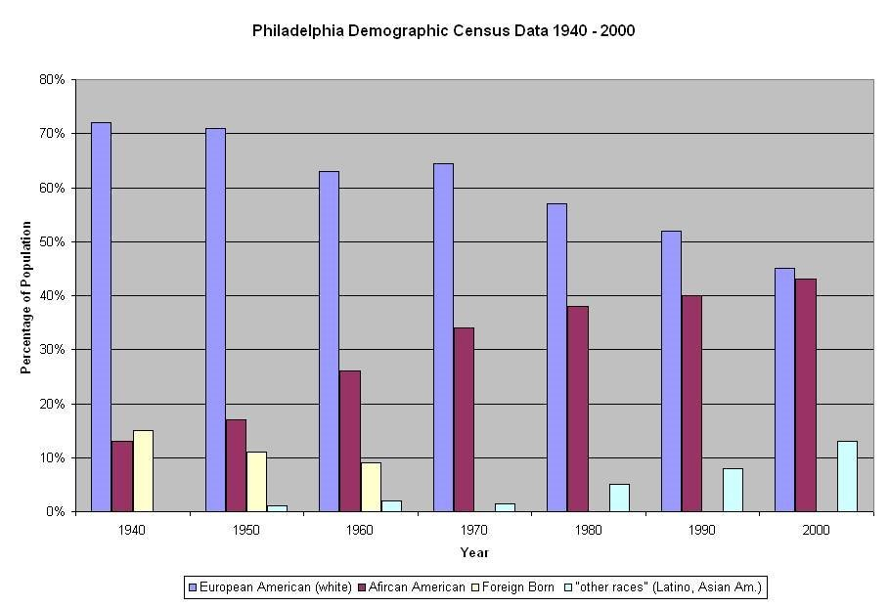U.S. Census data until 1960 included a "foreign born" category. The data is separate from African American and European American though immigrants represented different regions of the world. In 1950 "other races" was included." This includes Latino/as, Asian Americans and Native Americans / Pacific Islanders. (source: U.S. Census Data)  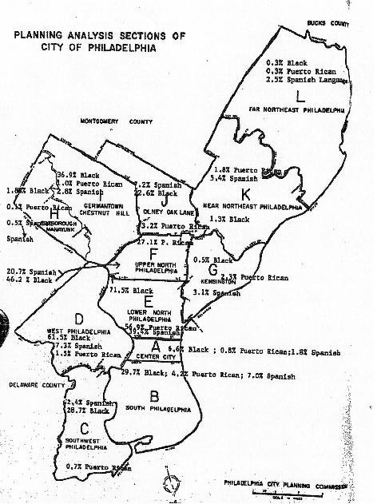Compiled from DESEGREGATION (1974)  Published by the National School Public Relations Association  We did not find information with this map. Therefore, we aren't positive how the map was used. Nevertheless, it appears to have demographic data that could be used for the School District voluntary desegregation program. We don't know why there is a distinction between "Puerto Rican" and "Spanish Language."  --------------------------------------------------------------------------------------------------------------------------------------  Northeast High School Pupil Enrollment (Source School District of Philadelphia Data)  **(until 1982-83, students were classified as "Black,' "white," and "other." In 1982 -83, American Indian, Asian and Hispanic were added.)  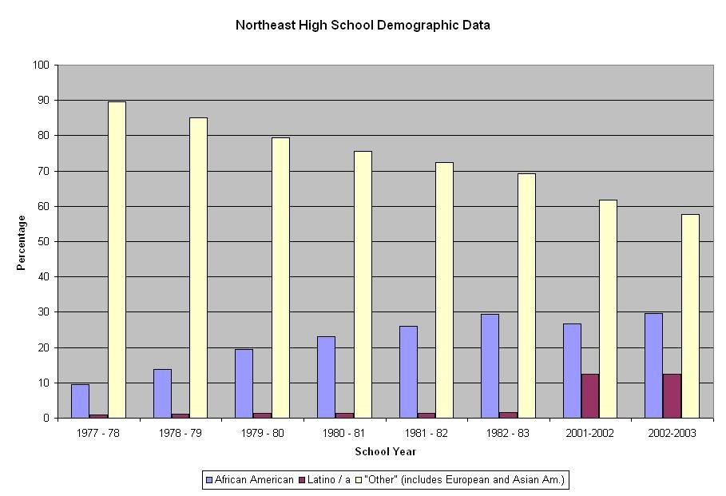  From 1977-78 - 1981-82, the School District listed "racial composition" as "Black," "Hispanic" and "Other." Therefore, we don't know the exact percentage of European or Asian American students. In 1982 - 1983, students were classified as "American Indian/Alaskan, Asian/Pacific Islander, Hispanic, Black (Non-Hispanic) and White (Non-Hispanic). Therefore, in 1982 -83, 66.7% of Northeast students were "white" and 2.4% were "Asian/Pacific Islander." In 2001-02, 51.3% of the students were "white" and 10.5% "Asian." In 2002-03, 45.4% are "white" and 12.4% are "Asian." (information from "Pupil Data" files from the School District of Philadelphia)  Northeast High School Instructional Staff (Source School District of Philadelphia Data)  **(until 1982-83, staff were classified as "Black,' "white," and "other." In 1982 -83, American Indian, Asian and Hispanic were added.)  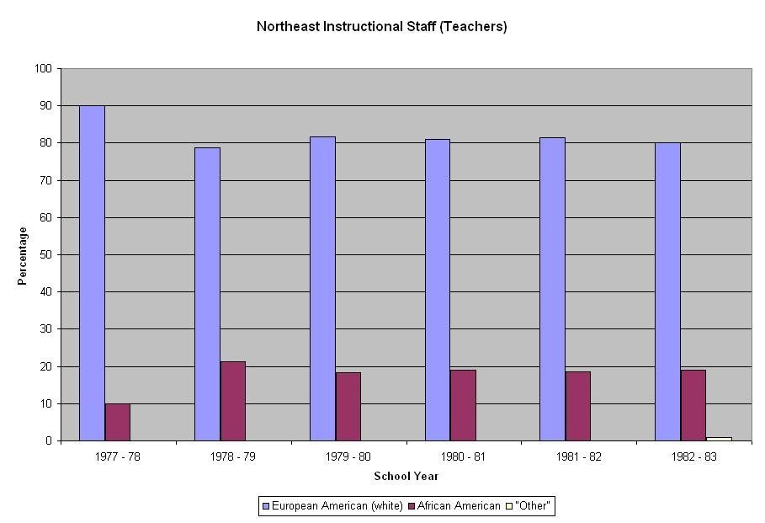  The School District from 1977-1982 listed instructional staff as "Black," "white" and "other." In 1982-83, staff were listed as "American Indian/Alaskan, Asian/Pacific Islander, Hispanic, Black (Non-Hispanic) and White (Non-Hispanic). In 1982-83, .08% of the staff was "Hispanic." There were no American Indian/Alaskan or Asian/Pacific islander teachers.

Articles from the Phila. Bulletin, Inquirer and Northeast HS Megaphone
Recent Demographic Data on Northeast High School (udpated in 2009)
Race/Ethnic Composition
YEAR | African  American | White | Asian | Latino | Other
2008-2009 | 35.9% | 27.4% | 20.5% | 14.6% | 1.5%
2007-2008 | 35.3% | 28.8% | 19% | 15.5% | 1.4%
2006-2007 | 35.2% | 29.7% | 18.2% | 15.8% | 1.1%
2005-2006 | 33.6% | 32.9% | 17.1% | 15.3% | 1.2%
2004-2005 | 32.2% | 37.8% | 15.2% | 14.9% | N/A
2003-2004 | 30.6% | 41.1% | 14.2% | 13.9% | N/A

Demo-  graphic  Data  Phila.  and  Northeast High School  Philadelphia's population in 1950 was over 2 million. Over 70% of the population was European American (white). By 2000, Philadelphia had less than 1.5 million people and the European and African American population was almost identical. The percentage of African American, Latino/a and Asian America students in the School District steadily increased. In 1940, 20.4% of the students in Philadelphia schools were African American. By 2001, 65.3 % of the student body was African American, 4.9% Asian American, 13.1% Latino/a, and 16.4% European American.  Northeast High School began a voluntary desegregation program in 1977 - 78 for staff and students. By 1982 - 1983, nearly 30% of the student body was African American. In 2002-2003, nearly 30% of the student body is African American. Today there are more Asian American and Latino/a students than in the late 1970s. Northeast continues to have a significant number of immigrant students from all around the world.  Changing Philadelphia Demographics  from presentation by Dr. Anne Phillips  Demographic changes in the U.S.:  During the 1950s, 1.5 million African American migrated from rural areas to urban areas  During the 1960s, 1.4 million African American migrated from rural areas to urban areas  Demographic changes in Philadelphia:  Between 1940 and 1950, 90,635 African Americans migrated to Philadelphia  Between 1950 and 1960, 64,974 African American migrated to Philadelphia  In the decade 1950 - 1960, Philadelphia's African American, Latino/a, and Asian  American population increased 41.2%; the European American population declined 13.3%  African American demographic isolation:  North and West Philadelphia became "virtually" African American  Racial change occurred quickly in Strawberry Mansion, Tioga and Southwest Philadelphia  Between 1930 - 1970, the index of African American isolation in Philadelphia rose from  27.3% - 75.6%  In the 1950s, Philadelphia's Puerto Rican community began to increase.  Demographics in Philadelphia schools:  The rapid transformation of the racial makeup of neighborhoods was matched in the schools  African American students enrollment went from 20.4% in 1940 to 47% in 1960  African Americans were the majority of students, 51%, in 1960 in elementary schools  Less than half of the European Americans students, 48%, were enrolled in public schools while 92% of African American students were enrolled in public schools | 1950s--------------------------------  11/ 1956 - (Governor) Leader Orders State Survey of School Desegregation (Phila. Bulletin)  "Governor Leader has ordered a statewide survey of desegregation in the public schools. The state school code specifically prohibits any distinction to be made on account of race or color in the assignment of any pupil, he pointed out. thus the school code is in conformity with the decision of the U.S. Supreme Court. As to the employment of teachers, the governor further notes that the recently enacted FEPC legislation clearly prohibits discrimination in the employment of teachers. ... The two pivotal questions are whether any schools are segregated and whether any Negro teachers are employed. The questionnaire (sent by the state superintendent of public instructions) also wants to know if Negro teachers are employed in the teaching of mixed classes of whites and Negroes and whether there is a school board policy, either written or unwritten, prohibiting the employment of Negro teachers. It also inquires whether activities sponsored by the school outside of regular school hours or so-called extracurricular ones during school hours are fully integrated. Specific information is asked on athletics, school clubs, dances, dramatics, journalism, music and debating clubs. It has been the policy of the Philadelphia public schools to very largely follow the pattern of the neighborhood of the schools served. Negro teachers have been appointed in the secondary schools for some time and Ruth Hayre, a Negro, was recently appointed principal of William Penn High.  2/6/57: School Segregation Survey Cloaked by 10 week silence: 1200 State Districts Got Queries (Phila. Inquirer)  "Ten weeks after the deadline for completion of a survey of segregation in the 1200 school districts of Pennsylvania, the results were still bottled up yesterday in the State Department of Public Instruction. ...The importance of the bottled up survey returns was highlighted in a letter to Gov. Leader by Floyd M. Logan, president of the Educational Equality League. After complimenting the governor on his civil rights recommendation to the Legislature for action on banning racial and religious discrimination in State-aided schools, Logan said: 'We would like very much to know the type of legislation you have in mind..."  5/15/57: State finds segregation in 3 School Districts (Phila. Evening Bulletin)  "Governor Leader las last night ordered the Dept. of Public Instruction to 'stamp out' racial segregation in 3 southeastern school districts. He named the districts involved as Kennett Consolidated and Coatesville and Steelton-Highpire. Governor Leader last November ordered the Department of Public Instruction to survey segregation. "  5/15/57: State Finds Segregation in Three School Districts (Phila. Evening Bulletin)  "Governor Leader last night ordered the Department of Public Instruction to 'stamp out' racial segregation in 3 southeast school districts...Kennett Consolidated and Coateville...and Steelton-Highspire.... Gov. Leader last November ordered the Department of Public Instruction to survey segregation.... The disclosure that the districts were still segregating Negro pupils three years after the U.S. Supreme Court had outlawed the practice set off considerable hubbub here. Segregation also is a violation of the 1935 equal rights law and a racial ban written into the school code in 1949. ... Superintendent of Public Instruction Charles H. Boehm at first refused to pointblank to name the districts. Then the former Bucks County superintendent of schools offered the somewhat inaccurate advice that the districts involved were 'somewhere along the Maryland line.' Finally, he said he was under orders from the governor to withhold the names.... The survey disclosed that the Chichester Joint District, in Delaware County, and the Valley Township District, in Chester County, maintain all-Negro schools with Negro instructors, but attributed this to an absence of white students. The department also reported that 49 school systems in 20 counties employ Negro teachers and none reported a ban on such employment. Prior to receiving this orders from the governor Boehm indicated his would have no part in halting the practice of segregation. 'The Department of Public Instruction is not charged with the enforcement of anti segregation laws...local parties must take their grievances to local courts. Of course, the Department of Public Instruction expects complete compliance with all state and federal statues as soon as possible."  5 Questions Asked on School Integration  The following five questions were asked of the state's 2,440 school districts in the segregation survey ordered by Governor Leader:  1. Are any schools of the area segregated?  2. Are Negro teachers employed in any of the schools?  3. Do Negro teachers, if employed, teach segregated classes?  4. Is there a school board policy, either written or unwritten prohibiting the employment of Negro teachers?  5. Are the activities sponsored by the school outside of regular school hours or so-called extracurricular activities during the school hours full integrated?  5/16/57: Leader to Cut Off State Aid If Schools Don't Integrate (Phila. Bulletin)  "Governor Leader today threatened to cut off state funds and invoke legal sanctions against Pennsylvania school districts that enforce racial segregation. ... Three districts - Coatesville and Kennett Consolidated in Chester County and Steelton-Highspire in Dauphin County - admitted to the Department of Public Instruction recently that they practice limited segregation of Negro pupils. The disclosure resulted from a statewide survey conducted by the department, after several Negro groups had complained to the governor. "If these districts do not eliminate segregation as they promised, or if in the future other cases of segregation come to light and the local authorities fail to take action to end such segregation, it will be the policy of the commonwealth to do everything within its power to eliminate it," Leader said. The governor said the state will use the threat of withholding subsidies and other appropriations and invoke legal action in the form of mandamuses and criminal actions against persons responsible for the segregation, as well as file complaints with the Fair Employment Practices Commission if districts discriminate against nonwhite teachers. Leader fixed October 1 as the deadline for compliance. Leader was asked whether Cheyney State Teachers College, which the Department of Public Instruction said today has an all-Negro student body and faculty, was not practicing racial discrimination. "I would assume there is no racial barrier at Cheyney," Leader replied. ..."They ought to try to get some white people to go to Cheyney and they ought to appoint some white teachers there," (Attorney General Thomas D. McBridge) said. The governor said he hoped an attempt would be made for integration of the Chester County institution. McBride said the segregation ban would also apply to school supported extracurricular activities such as dances, honor societies and Hi-Y Clubs. Several districts, including Scranton and Steelton-Highspire, reported that Negroes were barred from such activities... segregation was practiced by the (Steelton-Highspire)school's Hi-Y Club because its parent YMCA organization in Harrisburg also kept Negroes out of its main building."  -  "Gov. George M. Leader yesterday promised to use the full power of State law to stamp out racial segregation in the public schools. He said he expected the discrimination to be eliminated by Oct. 1, but that if it wasn't, he was prepared to take the following actions:  --Withdraw State appropriations to the offending schools.  --Withhold State subsidies for teachers' salaries.  --Legal action, through mandamus proceedings, to compel the end of segregation.  --Criminal action under the penal code against those responsible.  --Prosecution under the Fair Employment Practices law if there is discrimination against teachers.  Gov. Leader said that while he has se the Oct. 1 deadline, it didn't necessarily mean that he would 'throw the book' at any schools which hadn't complied by then - that this was a problem that required time to solve..."  5/28/58: Penna. Studies Plan for Wider Integration of Schools (Phila. Inquirer)  "The State is considering a proposal to require the public schools of Philadelphia and other communities to relax geographical school district boundaries in an effort to achieve wider integration through more equal distribution of white and Negro students.... There would be no 'order,' only recommendations, Dr. Seifert (deputy superintendent of public instruction) said, but he added that his department was empowered to withhold subsidies from local school districts that fail to comply with recommendations. The survey on which the State board will base its actions shows:  --Philadelphia, with a public school population of 233,877 - 59% of them white - has 19 schools that have virtually all Negro students, and 15 more with varying propositions of Negroes ranging from about 5% to more than 90%. There are 55 schools in this city that have either no Negro students or less than 1%. These are almost all in the far northern and northeastern sections of the city which have been spurting in population in recent years. There are no negro teachers in these schools, which is one of the main points of criticism of the National Association for the Advancement of Colored People and Education Equality League. Their demand is for full and immediate integration of teaching staff at once, but this policy is opposed by Philadelphia's superintendent of schools, Dr. Allen H. Wetter, who holds that integration can best be accomplished in more gradual way. 'If tomorrow we were to change school district boundaries so as to force white students into predominantly Negro schools, it would set the cause of integration back 25 years. White families would begin moving out of such gerrymandered neighborhoods.' The only way the schools can help solve the problem of integration is by means of the programs the city's schools are now following... which includes human relations activity, seminar and join extracurricular activities for white and Negro students and parents.... One of the obstacles toward immediate full integration of faculties, Dr. Wetter said, is that there is a 'teachers market' now with 600 vacancies in the city schools and teachers pretty much able to select what schools they desire without fear of losing their places on the eligibility list. In 1956, Floyd Logan, president of the Educational Equality league, submitted a report to the State Department of Public Instruction showing that of 8100 teachers in Philadelphia, 1611 were Negroes.  --Results of the Survey: "... there were 52 elementary, 2 high and 6 junior high schools with more than 50% of the students Negroes. The high schools included William Penn (79.1%) and Benjamin Franklin (76.3%); 13 elementary schools have 100% Negro attendance..."  9/13/58: Pennsylvania School Integration Picture (Pittsburgh Courier)  "Overshadowed by the more critical Little Rock, Ark. situation, the Pennsylvania State Department of Instruction, Aug. 14, made a momentous announcement. The release declared the end of segregation in schools in the commonwealth by virtue of the integration of schools in Coatesville, Kennett Square, and Steelton. The announcement made pleasing music to most of the citizens anxious to see their great Keystone State spared the pangs of this particular social blight. But it still sounds off key to the Educational Equality League with headquarters in Philadelphia, headed by Floyd L. Logan, president. Logan's organization has been a constant thorn in the side of the State Department of Instruction, and in the hair of Pennsylvania's last 4 or 5 governors on the school integration issue. In response to the general announcement of August 14, Logan took exceptions that strike extremely painful notes to the state and local education departments. Said in his letter to Gov. Leader, in part: 'Even after desegregation in this aforementioned schools areas takes place, there will still remain any number of segregated schools in student bodies as well as faculties in Chester, Allegheny, Philadelphia, and a number of other counties, that have not resulted from segregated housing altogether, but also from a system of districting.' It is significant, therefore, that in May of this year, the State Department of Instruction, in another public release proposed to request the public schools of Philadelphia and other communities apparently employing the redistricting implications leaning to separate schools, to 'relax geographical boundaries' in order to effect 'wider integration.' ... there has been evidence in Philadelphia in many communities that either the system of 'redistricting' or a loosely hung transfer allowance is granted to white parents who choose to remove their children to schools in distant predominantly white neighborhoods. Logan's organization further avers that 'it is a fact, borne out of the state survey, that the services of many Negro teachers are not being utilized altogether on an interracial basis.' What amounts to official acknowledgment of this factor came to light in 1957 when a Philadelphia Board of Education representative at a Fellowship Commission meeting declared that a single Negro teacher had been assigned to the Chestnut Hill Area as part of a teacher training set-up. her assignment, it was pointed out, required that she make visitations to various schools and had no classroom responsibility. ... in November 1955, ...Dr. Allen H. Wetter, superintendent of Philadelphia schools, declared that 'undue haste' should be avoided on integration and the individual neighborhood should be ready to accept Negro teachers before they are placed in all schools... a 'peculiar' situation existed in the city , of 62 schools with entirely white faculties and student bodies, and 11 with all Negro teachers, and student bodies. There were also in 1955 15 schools where in the student population was entirely non-white, which pointed to a smattering of white teachers in 4 schools outside of either extreme. ... in 1957-58, teacher integration took a slight rise, but according to the Educational Equality League, Philadelphia still has 19 all Negro schools, faculty and students included. ... some 1200 school districts in the state hadn't completed the questionnaire (10 week after the survey deadline in November 1956). ... Only the fall school opening can completely reveal Pennsylvania's status on the school integration question, though the commonwealth with its advancements still lagging behind her adjacent sister state of new Jersey and New York, yet only slightly ahead of her two Southern border neighbors of Delaware and Maryland."  1960s-------------------------------------------  1/9/68: Board Ask to Spur Return of 22 to Germantown High (Phila. Bulletin)  "A group of parents of students at Germantown High School last night demanded the return of 22 girls whose parents recently transferred them from Germantown to Northeast High School. The Board of Education has revoked 12 of the transfers, but only three of the girls actually have returned to Germantown. The rest are still attending Northeast. ...the transferring pupils live in East Mt. Airy while attending Northeast High. Usually parents may transfer their children to any school that is not overcrowded. In addition, the Board allows parents to transfer their children by 'delegating' parental responsibility to a relative or close friend within the boundaries of the new school. This requires the student live full time with his designated parents. A school district investigation prompted by the protests of Germantown parents revealed that 12 of the 22 girls were not living in the area of Northeast High School ... Most of the parents have refused to send their children back for fear of reprisals by other students and because, they say, their daughters would be subjected to 'indecencies and threats' which caused them to seek transfers in the first place. .."  1/?/68: School Shifts Canceled for 12 White Girls  "White parents who recently transferred their 22 daughters from a predominantly Negro to a predominantly white high school protested yesterday against revocation of 12 of the transfers. The transfers from Germantown High to Northeast High were approved by school officials two months ago. This was shortly after the appearance at Germantown High of Negro militants Cecil B. Moore and Dick Gregory. The Board of Education subsequently revoked 12 of the transfers on grounds they were not valid. The protesting parents told a school official they will withdraw their children from public school if the Board insists they return to Germantown High....The Board revoked the transfers after an investigation revealed that some of the pupils were not spending their required time with their new parents.... One mother claimed she would not allow her daughter to attend a school 'where she fears using the bathroom because the kids get beat up in there.' Another mother said her daughter had been attacked and beaten on a bus returning from school last spring. ... Dr. Kelner (superintendent of District 6 where Germantown High School is located), sympathized with the parents' concern and fears, but said the Board could not allow parents to resort to loopholes and 'subterfuge' as a way of transferring their children to an all white school. The parents insisted their actions were not prompted by considerations of race only of security for their children. ...Northeast High School has about 30 Negroes in a student body of 4,000. Germantown High also with about 4,000 pupils, is 69% Negro. ... School officials are withholding all parental authority transfers pending an investigation of the policy. Some have said it may be eliminated."  10/12/69: Northeast's Middle Class Feels Neglected by City (Sunday Bulletin)  (includes photo of "North Philadelphia Children are brought by buses to Gilbert Spruance Public School")  "... Schools are a key problem in many other parts of Philadelphia. In the Northeast, though, the problem is compounded by the population explosion. Until after World War II, there wasn't a single public high school in the entire section. Now there are three - all enormously overcrowded.... At Cottman and Algon Aves., Northeast High, with 4300 students, is on three shifts... Of Philadelphia's political leaders, a 29-year-old mother of two daughters declared heatedly: 'At election time, they want your vote, at tax time they want your dollars, but nothing else. The poor have welfare, the rich have money. What do we got? Mayor Tate is so busy trying to get the Negro vote in North Philadelphia, the Italian vote in South Philly, the Jewish vote in Oxford Circle - I'll never vote for him.' Northeast residents have been stung by the tag put on their section as a 'lily white' refuge for bigots fleeing Negroes. The charge gained wide currency after delegations of parents from the Northeast demonstrated at the school board headquarters in September 1968 against the Board desegregation plan. Under the plan, massive city-wide busing would have been undertaken - white children to black schools and vice versa - to provide integrated classroom experiences for all children one day or two days a week. Northeast mothers say the plan was unacceptable to all parents groups regardless of race, creed or color. But it was the Northeast that got the credit - or blame - for killing the scheme.... In the OOxford Circle area, two elementary schools, the Spruance at Levick and Horrocks Sts. and the Carnell at Devereaux and Summerdale, have been receiving Negro children from overcrowded North Philadelphia schools for four years. Both schools were all white before the busing began. While no organized opposition has surfaced among the white parents, there was and is much unhappiness. The concern is that a decline in standards is likely because poor Negro children are being transported from the ghetto with its education-defeating conditions, into middle class, predominantly Jewish schools where children are highly motivated."  "To ease the transition Spruance parents sought tutorial help and extra services and supplies from the School Board. The Board failed to act, however , and the Negro children at Spruance and Carnell are thus on their own....The entire Oxford Circle section is all white and always has been. But in knocking on doors at random, one senses a widely felt concern lest the neighborhood change, and change rapidly. There are no signs of the kind of overt hostility to Negroes that might lead to rock throwing and rioting should a nonwhite family move in. There are fears, however, of panic selling, mass flight and deterioration of the neighborhood. Mrs. Tomar (president of Spruance's Home and School Association) voiced a widely held opinion that factors other than racism are at the root of much of the opposition to racial change. ' We would all be extremely unhappy to see the neighborhood change completely,' she said. ' It would be very expensive to move and that's why everybody's holding right. Neighborhoods that have changed have big problems. It sounds like you're strictly a bigot if you oppose change. But it's really out of fear - fear of what has happened in every neighborhood that has changed. It's the same with busing. Parents here aren't afraid of having their children go to school with youngsters who are different. It's not white children mingling with black children per se, but the mater of safety that parents worry about.' Mrs. Tomar sees the problem of neighborhood change as one not just of race but of economic class. ' When prices drop as a neighborhood starts to turn, a lower class element comes in. Those who run first figure they'll get out while they can. Gradually even those who stayed get out to avoid ghettoization. The neighborhood becomes rough, crimes goes up and you have a low class ghetto.' ... Down the street... Mrs. Dabrow said she thought Oxford Circle could survive integration 'if the people wanted to survive it.' ...she is convinced her daughter, a fourth grader at Spruance, had benefited from the racially integrated situation. ...She also said, however, that in her opinion, 'the School Board made a big mistake in busing (Negro) children without supplying the needed supportive services.'  Late 1960s / early 1970s (Phila. Bulletin) (no date - article is next to an article "Agnew, Nixon Praise Tour of Asia Nations" on Agnew's tour of "South Vietnam" and the "Vietnamizing the war") Black, White High School Pupils Join 'Live-In' to Foster Friendship  "They're calling it a 'live-in' and the idea is to nurture black-white friendships among high school pupils. The white pupils are from Northeast High and the black pupils are from West Philadelphia High. Starting Last night about 20 from each school took up residence in what was once the power house of the Elkins estate in Elkins Park. The house is now St. Catherine's House, part of the Dominican Retreat Center. The West Phila. pupils, each with a Northeast buddy, will be going to classes at Northeast High this week. Next week the West Philadelphia pupils will be the hosts and the Northeast pupils the guests. At night they return to St. Catherine's house for special programs and discussions. Over the weekend, they'll go home. The live-in is part of an 'ethnic literature' program devised by Dr. Irene M. Reiter of Northeast's English Department. Ethnic literature pupils read Afro-American, Indian-American, Jewish-American... to round out their understanding, they're trying to grasp what it feels like to be a minority member in America. The WEst Philadelphia students, under the tutelage of Lester Coggeshall, are reading most of the same materials in a comparable ethnic literature course. About once a month, the two groups have been getting together for shared experiences..."  1970s----------------------------------------  1/10/75: Schools to Integrate - For 1 Day a Week (Phila. Daily News)  "School District planners have been ordered to move full-speed ahead with a new desegregation plan that officials hope can be start, at least on a pilot basis, this September. The plan... calls for the establishment of specialized 'academies' in each of the city's eight school districts. As envisioned, pupils in each of the city's schools would spend one day a week in the 'academy' of their choice, taking courses in art, science, music, language and math. The effect... will be to cause 'meaningful integration' for each of the city's 270,000 pupils at least one day each week while pressuring the neighborhood school' concept on other school days. This plan will not affect a full desegregation plan that includes mass busing of pupils that is currently being prepared by the School District for submission to Commonwealth Court Judge Roy Wilkinson Jr. Judge Wilkinson has given the School District and the State Human Relations Commission until the end of this month to submit plans for the full desegregation of the city's public schools. He then will decide which plan or which parts of both should be implemented. ....The School District planners will have to explore busing schedules, available facilities and faculty needs before the plan can become a reality. On any school day, as many as 55,000 pupils will have to be bused to and from their home school to an academy. Each neighborhood school would be over-enrolled by 20 percent to compensate."  4/19/77: Percentage of black is up in schools (Phila. Inquirer)  "After remaining unchanged for two years, the percentage of black students in the city's public schools increased slightly last year, according to statistics released by the school district. The school district is now 62.2% black, up from 61.7% during the 1974 - 1975 and 1975 - 1976 school years. The percentage of Hispanic students climbed from 5.2 to 5.5. The increased percentages resulted from a drop of nearly 4,000 pupils in white enrollment.... Five more schools qualified as segregated last year under guidelines established by the State Human Relations Commission. That means 235 of the city's 280 schools are considered racially imbalance."  1/8/79: Bias Charges are Disputed by Marcase (Phila. Bulletin)  "Philadelphia School Superintendent Marcase last night defended School District policies in the face of a federal Office of Civil Rights (OCR) report that said the district had violated civil rights laws....It accused the district of fostering racial segregation and violation of civil rights laws between 1975 - 1978 by allowing white students to transfer out of predominantly black schools in their neighborhoods. The OCR report said 54 white students in the Logan, Oak Lane and Olney  y sections of the city were allowed to attend predominantly white schools, out of their neighborhoods....Marcase said the school district didn't adopt OCR guidelines until Sept. 1978 and they didn't go into effect until 1979...He said the report shouldn't have any effect on federal funds, since it involved only about '30 students out of 240,000' in the school district... In other action, the board renewed a 6 year old pledge to replace the deteriorating Edison High School... With Frank L. Rizzo no longer mayor, school officials are hoping the reception at City Hall will be warmer ... partly because its location would foster integration.... however, Councilman Harry P. Jannotti said he strongly opposed the proposal to build both a new high school and vocational skills center on the site.... The location of the new building to replace the dilapidated 77 year old Edison High... has been the focus of dispute for more than 2 decades. The 1,800 students at Edison are almost all Black and Hispanic, while the population near the proposed relocation site is mostly white."  2/11/79: Magnet schools plan drawing inner-city kids (Phila. Bulletin)  "Carl Adams sacrifices extra sleep and endures more than 10 hours of travel every week in an effort to obtain a better education. Adams, 12, ...(takes) classes at Wilson Junior High School in Northeast Philadelphia.... Mrs. Slaffy (mother), a Postal Service window clerk at the Roxborough post office, said she heard from other parents that standards had dropped at the predominantly black junior high school in West Philadelphia that Carol normally would have attended. She said she would have preferred to send her son to a neighborhood school, and didn't like the idea of two hours of bus travel each day. But the promise of direct travel by school bus convinced her that Wilson was the preferable schools. Young Adams is one of an estimated 3,000 Philadelphia public school children who are participation gin the Board of Education's voluntary desegregation plan. Most are black (like Adams) or Hispanic and they are attending predominantly white schools. They are lured by the reputations these schools have for superior programs and performance or by such "magnet" concepts as improved teaching techniques. About 1,500 of the minority pupils are being bused to schools in district 8 in the Far Northeast. District 8, with an enrollment of 33,150 pupils, is one of the only 2 city school districts with more white pupils than minority ones. Prior to the influx of black and Hispanic pupils last September under desegregation efforts, 94% of the district 8's pupils were white. So far, the program appears to be going smoothly. ... 'We're not getting inner city kids here,' reported Harriet Gelbert, a counselor at Wilson, when asked if the minority pupils had any effect on achievement levels at the school. 'Some of them are higher academically than our other kids,' said Mrs. Gelbart. .... Most of the minority pupils in district 8 are in the schools in the district's lower tier. As a result, the enrollments at four schools - Solis-Cohen, Lawndale and Moore elementary schools and Fels junior high - are 25% minority thus meeting the guidelines for desegregated schools... Provided there are enough applicants, said Benjamin J. Kaplan, district 8 superintendent, declining enrollments will permit Baldi and Rush Middle Schools and Holme, Pollock, Allen, Greenberg and Comly elementary schools to accept minority pupils next year. Kaplan said the district's goal is to have all schools desegregated by 1981 - 82...."  7/3/79: High Court upholds busing rule, deals anti-integrationists a blow  "The battle against public school desegregation in Philadelphia and other northern cities has been dealt a severe setback by the U.S. Supreme Court. In upholding districted busing orders in Dayton and Columbus, Ohio, yesterday, the high court also brought bad news to anit-integration activists in Delaware. In fact, the rulings spell a virtual end to efforts to overturn the year old court ordered school desegregation plan in New Castle County, Del., which itself took nearly 25 years to achieve. The decisions are potentially as important to northern school districts as the high court's 1954 opinion banning separate segregated school systems was to southern districts. Civil rights groups hailed the rulings as a signal that federal courts could be counted on to fulfill their commitment to end racial isolation in the north's school districts, even if it involves massive and unpopular busing. The high court ruled 5 - 4 in the Dayton case that when school officials are found to have adopted policies that have encouraged racial segregation in the large part of a school district, the remedy for such violations must involve system wide desegregation, even if those policies are no longer in force. But if district officials can prove their actions did not cause racial isolation in their schools as much as did housing patterns or other factors other which they had no control, the court ruled, they need not be forced to desegregated. ... In Philadelphia, the Board of Education last year, abolished so-called 'optional areas' under which white pupils were allowed to attend predominantly white schools, even thought they may have lived closer to a school where most pupils were Black or Hispanic. The repeal of an attendance area plan which encouraged white pupils in the near Northeast to enroll at Frankford High School rather than Edison High in North Philadelphia has created controversy in the neighborhoods affected, and brought demands that the Board restore the opinion. But Assoc. Superintendent of Schools Richard D. Hanusey, who coordinates voluntary desegregation in Philadelphia, said yesterday that the high court's ruling made clear the courts would not tolerate any retreat from the district's move toward integration. '... if we are not successful with our voluntary desegregation, there is no question in my mind there will be an extensive busing pattern,' Hanusey said. The district's voluntary desegregation plan, which took effect in February, has been a success in moving black students into white schools but a failure in achieving the reverse. School officials concede pockets of segregation will remain in the district even if the voluntary plan works.  8/21/79: Board Waivers on High School Desegregation (Phila. Bulletin)  "The Phila. Board of Education is thinking of amending its voluntary desegregation plan to accommodate white pupils who say they will not attend two high schools with predominantly black and Hispanic enrollments. But school officials warned that such an action - the result of intensive lobbying by white parents, politicians and community leaders in the near Northeast - would undermine the district's already lagging integration effort. Board Pres. Thomas said yesterday that members will meet next week to consider restoring an 'optional' attendance area that now permits white pupils from parts of Kensington, Richmond and Bridesburg to enroll at Frankford High School rather than Edison or Kensington High School. Historically, almost all of the pupils have chosen to attend Frankford in District 7, where the pupil enrollment is 85% white, rather than either of the District 5 high schools, where whites make up less than 15% of the student body. The board voted 4 - 3 in April to eliminate the optional area and assign its pupils to Edison and Kensington to foster integration. Both schools have dropped their single sex designations and will become co-educational when classes begin Sept. 6. About 80 10th graders were scheduled for reassignment from Frankford next month in the first year of a 3 year plan. Eventually, more than 200 pupils would be transferred to Edison or Kensington under the new attendance boundaries. But parents of pupils involved said they would not allow their children, to attend Edison or Kensington, citing fears of violence, the schools' high dropout and absentee rates, low scores and the aged and crumbling buildings. About 25 parents, led by State Rep. Robert a. Borski, who represents the area, pressed the concerns yesterday during a special meeting with the board..."  8/31/79: Local TV balks at school desegregation ads (Phila. Inquirer)  "The Phila. School District is having trouble buying time on local television stations to advertise its voluntary desegregation plans. An ad reviewer for WCAU, Channel 10, told producers of the 30 second spots last month that two of the school ads were unacceptable because they were 'controversial.' KYW, Channel 3, has offered to broadcast the ads for free as public service announcements but will not guarantee when they would run... WPVI, Channel 6, has sold time for some of the ads but not all. The most difficult ad to place... is one in which school board member Augustus Baxter says: 'Philadelphia is a fine city of neighborhoods. Today we have a chance to desegregate our schools without federal intervention. As people of good will, and at the eleventh hour before court mandate, parents and children might examine new quality educational programs. Make choices wherever these programs are. Visit your schools. Give our plan a chance. We do not need to be a Boston or a Louisville. We are Philadelphia's.' ...Another ad deemed 'controversial' features an interracial group of students at the High School for Creative and Performing ARts discussing their decision to move from their neighborhood schools, ' It think it's great,' one says, 'There are kids from so many different racial and ethnic backgrounds here and we are communicating and working together.' (The controversy was the 'euphemistic comment' on desegregation - different ethnic and racial backgrounds working together.') ... It also bothered her (Florence Satinsky, WCAU manager for continuity acceptance) that in another ad Phillies short stop Larry Bowa urges parents and children to 'check out' new school programs designed to entice children to change schools and enhance racial balance....'this is exhortative and it urges youngsters to pressure their parents to act on a concept - which, while thoroughly admirablee, unfortunately becomes judgmental... Charles Bradley, WPVI program director, said yesterday that the Baxter ad violates the federal Communications Commission's Fairness Doctrine, 'Because of the doctrine, WPVI does not sell time to controversial issues. Desegregation is a very controversial issue in Philadelphia..."  9/11/79: Pupil shifting studied again (3rd time in 4 months) (Phila. Bulletin)  "For the 3rd time in 4 months, the Philadelphia Board of Education will reconsider its assignment of 80 white pupils from the near Northeast to predominantly minority Edison and Kensington high schools to foster racial integration. After nearly 100 pupils, parents, and community leaders affected by the shifts demonstrated yesterday at the School Administration Building and outside Frankford High School, Board president Arthur W. Thomas said the board would meet this week to "review" its policy. ... Pupils living in the area affected by the reassignments, which includes parts of Kensington, Richmond, Bridesburg, and Harrowgate, ordinarily would have attended Frankford High... the Board voted in April to make Edison and Kensington co-educational this year and assignment graduating junior high school pupils from the optional area to those schools, rather than allowing them to enroll as 10th graders at Frankford. ... Parents said they would not allow their pupils to attend the district 5 (Edison and Kensington) High School, citing their high dropout and absentee rates, decrepit facilities, and low scores on standardized tests of basic skills.... State Rep. Robert. Borski, Jr. who led yesterday's demonstrations, argued that the attendance area was neither optional nor a special privilege, since he said pupils had been assigned automatically to Frankford without filing transfer requests for at leas the past 30 years.... Commonwealth Court is scheduled to review the district's desegregation plan next February, and could order mandatory busing if it determines the district has not met its integration goals. ...'This issue could have the impact of maintaining segregation,' Marcase (School Superintendent) said.... Enrollment at Frankford High School last year was 85% white. Black and Hispanic pupils made up more than 85% of the students bodies at Edison and Kensington."  9/18/79: Pupils insist on admission to Frankford (Phila. Bulletin)  "Many Philadelphia public high schools are plagued by high dropout rates, but at Frankford High School, it's a different story. About 10 parents and pupils met there today with principal James Peters to demand admission to the school. And last night, parents in the city's lower Northeast section had threatened to slip their children inside Frankford beginning today to subvert the assignments to Edison and Kensington high schools. ... At a meeting at Kensington Ave. and Tiogra St. in the Harrowgate section, parents from parts of Kensington, Richmond, Harrowgate and Bridesburg said they would step up their demands that the Board of Education permit their children to attend Frankford... The school board voted yesterday not to reverse its resolution of last April in which attendance boundaries for Edison and Kensington were redrawn. The plan assigned about 80 10th grade pupils from the option area to the District 5 (Edison and Kensington) schools in September in a move aimed at improving racial balance....'Are we just going to stand by and do whatever (board members) tell us to do?' Rep. Borski shouted through a bullhorn, 'Or are we going to fight this giant swindle with everything we've got?' ... Borski also called for picketing by parents during school hours at Frankford's campus at Oxford Ave. and Wakeling Sts. He said he would seek apprenticeships with local unions for pupils interested in vocational programs. The voluntary racial desegregation plan the board approved in February 1978 called for the elimination of all 'optional' attendance areas, parts of the city where pupils were given a choice of several neighborhood high schools. In effect, the policy often allowed white pupils to choose between schools where enrollments were predominately white - such as Frankford - or predominately Black or Hispanic - such as Edison and Kensington. ...(Parents) said their opposition to the assignments is not racial, but based upon the aging facilities, high absentee and dropout rates and low standardized test scores ... The Citizens Committee on Public Education in Philadelphia also argued against restoring the Frankford option, calling it a 'disgraceful escape hatch that (separates) white children from nonwhite children.' ... Borski said he probably will introduce a bill in the Legislature to prevent the school district from collecting subsidy payments for students who do not attend the schools to which they are assigned. Borski also said he was challenging the pupil assignments in Philadelphia Common Pleas Court."  9/21/79: Politicians join Frankford High Rally (Phila. Bulletin)  "The teen-age girl waved last night from the grill covered, second floor window at Frankford High School. 'Hi Daddy', she squealed, ' I love you.' She was among a handful of pupils who joined 23 parents in occupying the high school at Oxford Ave. and Wakeling St. for the second night. The protest entered its third day today. The parents vowed to continue their sit-in outside the school's main office until the Board of Education meets Monday morning. The protesters are demanding that the school board reverse its assignment of about 80 white 10th grade pupils from the city's lower Northeast to predominantly minority Edison and Kensington high school to improve racial balance at the schools... State Rep. Robert A. Borski, leader of the protest, staged two rallies last night in support of the Frankford occupation, at the school and in Harrowgate Park ...Each attracted more than 100 person, including some of the city's most prominent politicians.... City Councilman Francis Rafferty, an at-large Democrat from Grays Ferry, called the pupil assignments 'a disgrace' at the Frankford rally. 'This is like Russia, like Communist Poland,' Rafferty told the cheering crowd, 'Fight together and don't let them force this on you. This is only the beginning. You are setting a precedent for the whole city.' ... City Commission Chairman Margaret M. Tartaglione, another Democrat, also endorsed the parents' fight to keep their children in Frankford where the pupil enrollment is 85% white. 'They say I got a big mouth, well it keeps me from getting pushed around. So let's show them what we women can do.' ...Two reading teachers at Kensington High School, Carol Adams and Jennifer Beyer, appeared at the Frankford rally to defend the quality of education at their school. They were quickly surrounded by angry parents who shouted them down. ' We understand their concern,' Ms. Beyer said later, visibly shaken. ' We just wanted to tell them to come into the school and watch what's going on before they make up their minds. We care, too - the school's not as bad as it appears to be.'"  10/12/79: School Receive reduced grant for integration (Phila. Inquirer)  "After troublesome negotiations with the U.S. Office of Education, the Philadelphia School District has been awarded only $1.4 million of the $3.9 million it had requested for 'special projects' to encourage desegregation.... The funded projects will begin between now and Feb. 1, 1980 at 12 racially segregated schools ... The Emergency School Aid Act gave the school district almost $5 million for its voluntary desegregation plan earlier this year, and the Board of Education allotted another $4 million for the effort. ... The school system is acting under a 1968 order from the Pennsylvania Commission on Human Relations to desegregated its schools, more than a third of white are at least 90% black. ... Special projects to be funded by the Office of Education include an 'academy for academic excellence' for advanced students at Jenks Elementary in Chestnut Hill and an 'instructional enrichment center' at Girard Elementary, a predominantly white South Philadelphia school that merged last month with the mostly black Poe Elementary... Allay kindergarten programs will be added to Bache, Wayne and G. Washington elementary schools, a bilingual program for Hispanic children will start at John Moffet elementary and a new music program will begin at Shawmont Elementary ..."  (no date): Few parents travel to see Philadelphia schools (Phila. Bulletin)  "In the name of racial integration, the yellow buses shook, rattled and rolled yesterday between Northeast Philadelphia and several of the city's black schools. The busing lasted less than 5 hours. It attracted fewer than 20 participants. And they were parents, no pupils. This is open house week in the Philadelphia School District, as school officials are encouraging parents to examine the special academic centers and alternative courses of study offered under the district's voluntary desegregation plan. Like the integration effort itself, the house parties have enjoyed only one-way success. More than 260 parents signed up for 16 bus tours to visit schools involved in the voluntary program, according tot he district figures. Barely one tenth were white.... Yesterday's trip from the Far Northeast to the district's showpiece 'magnet' high school for science and engineering on the Temple University campus in North Philadelphia attracted only a dozen parents. And it was the most successful of two tours.... parents expressed admiration for the special programs at the schools they had visited but said they weren't ready to send their children to them... the concerns expressed in the questions they asked the school principals were hardly academic: How long a bus ride is it? Is there a cafeteria? Will young children have to ride public transportation? What if they get sick during the day? How can they take part in after school activities? How involved are the parents? As they rode back to the Northeast along Roosevelt Blvd., the parents described their reluctance to commit their children to schools on the other end of the city...'I love other programs ...but that 95% black majority (enrollment) bothers me. My daughter's only in 3rd grade and I don't think she's cut out to be a pioneer...but it's really frustrating. You want to see your kid get the best education available - why can't they have quality programs in all the schools?"  1980s - 1990s ------------------------  10/1/80: School Desegregation is touted in ad drive (Philadelphia Bulletin)  "The Philadelphia School District will start a $100,000 public relations campaign this month to promote its voluntary desegregation program.... 30-second radio and television spots were being taped by a local public relations firm this week... The financially troubled desegregation program has been called 'totally inadequate... only about 8,000 public school students, out of more than 220,000, have transferred voluntarily into special interest magnet schools outside their home districts. Last July, a suit was filed by the Pennsylvania Human Relations Commission in Commonwealth Court seeking to force the district to implement a mandatory school desegregation program.... The U.S. Department of Education informed the district it would grant it only $5.2 million in Emergency School Aid Act funds to support the desegregation program for the 1980 - 1981 school year....$5 million short of what had been sought..."  10/16/80: Hearing Off on Deseg (Philadelphia Bulletin)  "A court hearing that could mean the beginning of mandatory desegregation program for 220,000 city school children has been postponed until next January, giving the Pennsylvania Human Relations Commission additional time to prepare its case against the School District. .. Impatient with the school board's voluntary desegregation program, which began in 1979, the commission sued the district in July to show cause why the district should not now be forced to use such alternatives as busing, pupil reassignment, redrawing of boundary lines, or merging white and black neighborhood schools, to achieve racial balance in the classroom. If the court rules that the system must switch to a mandatory plan, the Board of Education would be given 90 days to develop it and would have the option of selecting which methods to implement...."  1/81: Speed-up of school integration in Philadelphia urged (Philadelphia Bulletin)  "The Pennsylvania Human Relations Commission, which has sparred with the Philadelphia School District over desegregation for 13 years, returned to court yesterday to ask for stepped-up efforts to achieve racial balance in the city's schools... would ask the court to impose a mandatory plan in Philadelphia to eliminate racial imbalance in all but elementary schools within a year of its implementation.... some children in 116 elementary schools, 14 junior high schools, 10 middle schools and 16 high schools would be reassigned if commission goals outlined early last year are adopted. Under those goals, the district would be free to redraw attendance areas, pair 21 schools, and rely on satellite and magnet programs to bring about racial balance. The current plan relies heavily on white students who choose to attend magnet programs in predominantly black schools. ... the district classifies a school as desegregated if white enrollment does not drop below 25% or rise above 75%. The commission, however, favors a more stringent definition that is says would require a greater percentage of white students, especially those from Northeast Philadelphia to switch schools to achieve racial balance. The Citizens Committee for the Preservation of Neighborhood Schools is expected to intervene later in the four day hearings, testifying that the district has had insufficient time and money to achieve voluntary desegregation."  1/22/81: Expert cites parochial schools as 'segregated' (Philadelphia Bulletin)  "A national expert on school desegregation testified yesterday that Philadelphia' parochial schools are 'probably more segregated than any public school system anywhere in the United States.' Dr. Robert Crain, a sociologist and researcher at Johns Hopkins University (said)... the availability of largely white parochial school system in Philadelphia makes desegregating the city's public schools more difficult....if Philadelphia went to mandatory school desegregation plan involving busing, 'the result would probably be more white flight than in public schools in the South.' The school district is currently attempting to desegregated the public schools through a voluntary plans. The plan includes enrichment programs to draw white children into schools located in black neighborhoods, as well as special 'magnet' middle and high schools, aiming at the arts, sciences and business. Another desegregation tool is the pairing of nearby black and white elementary schools. Since the plan went into operation in February 1979, the district claims the number of desegregated schools has climbed from 47 to 78 out of a total of 287 schools. By desegregation, the district means schools that are no more than 75% white or 75% minority. The district is currently about 28% white, compared with 31% in 1976. The Pennsylvania Human Relations Commission is suing the school district to go to a mandatory desegregation plan. Crain was a witness for the school district. The 'obvious option' for Philadelphia, Crain said, would be merging with nearby suburban school districts. 'There's a very large white student body in the area who are closer to Philadelphia's blacks than the whites in Northeast Philadelphia, ' Crain said, referring to Delaware and Montgomery counties. ... the school district's chief desegregation official testified that money was a serious obstacle to furthering desegregation in Philadelphia...."  1/22/81 Expert assails Phila. school over integration (Philadelphia Bulletin)  "A national expert on urban school desegregation testified yesterday that Philadelphia' voluntary plan is unfair to blacks and Hispanics. 'The program shoves the burden of desegregation on blacks,' said Dr. Gordon Forrester, Professor of Education at the University of Miami. 'You have a system where the black parent who wants a good education for his child finds the only way out is to send that child to a white school. This is an inequitable situation... forrester attacked Philadelphia's criteria for desegregation because a school with 25 - 75% white student population may be considered desegregated.... And he claimed the school district placed too much emphasis on magnet programs designed to attract students from all over the city. The school district has 10 high school magnet programs and has plans for three more. 'I've spoken against magnet programs because I don't think they accomplish much in terms of desegregation. They enhance the school district curriculum, but they are extremely expensive..."  10/4/83: No Busing in Board's New Plan (Daily News)  "The Board of Education has been trying for 15 years to desegregate city schools without mandatory measures. Yesterday, it unanimously approved a plan that focuses on the voluntary integration of 34 schools, including four high schools, within three years.  The plan presented by Schools Superintendent Constance E. Clayton to a special board meeting calls for desegregation by the 1986-87 school year of 88, or about 33 percent, of the city's 267 schools. "It is imperative," Clayton said in presenting the plan, "that we turn our attention from litigating to educating." The plan was to be submitted today to Commonwealth Court President Judge James C. Crumlish, meeting a deadline the judge had set in April 1982....The commission has been trying to force school integration here through the courts since the late 1960s....Clayton had revealed the thrust of her plan - including its rejection of mandatory busing - in a series of preliminary reports issued to the board during the past three months. She has opposed busing - or any other mandatory measure - on the ground it would drive away white students, making desegregation even more difficult.  The new plan was written primarily by Ralph Smith, a University of Pennsylvania law professor working as a paid consultant. It includes three main components:  * Improving education throughout the school system, especially at 73 schools where student achievement has been lowest.  * Increasing by two thirds the number of students who attend schools at which they are among the racial minority. This is to be done by targeting 34 elementary and secondary schools for voluntary pupil transfers and other measures. Among the targeted schools are Kensington, Olney, Frankford and Northeast high schools.  In the last school year, 9,500 of the district's 207,000 students voluntarily transferred to schools at which they were among the racial minority. Officials plan to increase the number of such transfers at the 34 schools to 14,500 by the 1986-7 school year. The plan sets specific transfer goals for each school.  * Reducing "racial isolation" at 116 schools that would remain more than 90 percent black or white by, among other means, bringing these students together for special activities.  Since 1968, when the Human Relations Commission first ordered the district to desegregate, school officials have adopted various integration plans, all of which have depended on persuading parents to voluntarily send their children to schools outside their neighborhoods. Though the commission has argued, and Commonwealth Court has agreed, that previous efforts have failed - two thirds of the district's black students still attend schools that are 90 percent or more black - school officials argued yesterday this plan would work..."Previous plans only dealt with the physical desegregation of students. They have neglected to include a proposal for educational improvements," school board member Helen Oakes said in a prepared statement.  Asked why she thought a renewed attempt at voluntary transfers of students would work this time, Clayton said, "One of our surveys indicated that half of the parents didn't even know they could voluntarily transfer their children to a different school. We need to do better marketing . . . . " A school would be considered desegregated under Clayton's plan if it had between 25 percent and 60 percent white enrollment and between 40 and 75 percent minority enrollment. The total student population now is 63.3 percent black, 26.2 percent white, 8.2 percent Hispanic and 2.3 percent Asian."  10/11/83: School Integration Plan Rejected by Rights Unit (Daily News)  "The Pennsylvania Human Relations Commission yesterday overwhelmingly rejected the voluntary desegregation plan proposed by Schools Superintendent Constance E. Clayton on the ground that similar efforts have not been successful. The commission, voting 5-0 with one abstention, believes the Philadelphia schools should use more "traditional desegregation devices," including mandatory busing when necessary, commission executive director Homer Floyd said. "The methods that were relied upon to voluntarily desegregate the schools have failed in the past and the commission saw no substantial assurance that they will be successful in future voluntary efforts," Floyd said. "We felt the plan did not utilize the traditional desegregation devices, such as . . . reassignment of pupils from one school to another." Clayton said she was disappointed, but not surprised that the commission rejected the plan....If the court also rejects Clayton's plan, the Board of Education will have to develop a new scenario or face mandatory busing. The commission could elect to appeal if the court accepts the voluntary plan. Clayton has argued that mandatory measures would cause students, particularly white students, to leave the system, making desegregation more difficult. Commission members say the plan places a disproportionate burden on black students...."  10/25/83: Board, Rights Commission OK Desegregation Plan (Daily News)  "The bitter 15-year school integration fight between the Pennsylvania Human Relations Commission and the Board of Education ended yesterday as both bodies voted separately to approve a plan that will seek to voluntarily desegregate 48 schools during the next five years. The votes, unanimous on the board's part and 7-3 by the commission, were seen by most observers as a victory for Schools Superintendent Constance E. Clayton, who has tried for months to break the impasse between the board and the commission, end any possibility of mandatory busing and, in her words, turn the school system 'from litigating to educating.'....Schools to be desegregated by 1986-7 under the agreement are:  Elementary: Penrose, Fell, Bache, A.S. Jenks, Taggart, Cassidy, H.A. Brown, Richmond, Henry, Houston, Barton, Ellwood, Franklin, Lawton, Olney, Sullivan, Webster, Allen, J.H. Brown, Moore, Solis-Cohen, Spruance, Rhawnhurst, Farrell, Creighton and Crossan.  Junior high and middle schools: Fels, Vare, Thomas, Wilson and Meehan.  High schools: Saul, Kensington, Mastbaum, Frankford, Olney and Northeast.  Schools to be desegregated by 1988-9 are:  Elementary: Carnell, Edmunds, Hopkinson, Feltonville, Sheridan, Disston, Forrest and Bridesburg.  Middle schools: Rush and LeBrum.  High schools: Washington and Lincoln."  7/18/84: Teacher Deseg. Plan OK'd (Daily News)  "A federal appeals court has upheld the Philadelphia School District's policy of teacher transfers to achieve faculty integration.  The U.S. Court of Appeals for the Third Circuit ruled yesterday the transfer program was "racially neutral," requiring the transfer of both black and white teachers, and had nothing to do with either the hiring or promotion of teachers. The suit was brought in December 1981 by four white elementary school teachers who complained the policy was discriminatory. Spokesmen for the teachers could not immediately be reached to determine whether there would be an appeal. But School District spokesman J. William Jones said Schools Superintendent Constance Clayton was "elated" because the policy "is really the core of our staff desegregation program." The policy was instituted in 1978 after the district was ordered to desegregate its faculty or lose federal funds amounting to more than $100 million. Under the policy, the proportion of teachers of a given race at a given school could not be less than 75 percent or more than 125 percent of the proportion of teachers of that race in the system as a whole. For example, if 40 percent of the district's elementary school teachers were black, each elementary school would be required to employ between 30 percent and 50 percent black teachers. Jones said the bulk of the transfers, about 3,000, occurred shortly after the 1978 order. Federal officials found that by June 1982 the district was ''substantially in compliance" with faculty integration and was under no further obligation to continue the 75-125 percent policy...."  11/20/84: Year of School Integration Gets High Marks (Daily News)  "School District officials are claiming initial success in their year-old school desegregation effort, announcing that 23 schools have become racially integrated since the voluntary campaign began last fall. 'Our progress exceeded our expectations,' an elated Schools Superintendent Constance E. Clayton told the Board of Education at its regular meeting yesterday. Desegregation 'will continue to be accorded the highest priority,' she added....Clayton and her staff reported that 21 of those 50 target schools are now desegregated, as well as two others not on the original list. A ''desegregated" school is considered one that is 25 percent to 60 percent white. Meanwhile, six other previously integrated schools became racially segregated, so the net gain in integrated schools was 17, the administration report indicated. But the 17 schools boosted to 71 the total of integrated schools in the system. The improvement means that this year nearly 50 percent of all white students in the district are attending desegregated schools, compared to only 29 percent in 1983... The district's current pupil population, according to figures released yesterday, is 197,600, of which 63.5 percent are black, 25.1 percent white, and 11.1 percent Hispanic, Asian and native American.  Through the intensive recruiting of minority pupils to predominantly white schools and of white pupils to predominantly black schools, the district achieved an unprecedented 30 percent increase in desegregation transfer requests this school year.  Recruitment of white students to predominantly black schools was aided in some instances by inducements such as all day kindergartens or special magnet programs in those schools...The greatest success in attracting white students to a black school was at Charles W. Henry School in Mount Airy, where the percentage of white pupils nearly doubled, from 17 percent to 32 percent, Smith reported. However, Smith acknowledged that 'most of the success at Henry has been in attracting students (from private and parochial schools) into the school system.' Few white pupils were transferring within the system, he said...."  11/7/87: School-Integration Hearings Due (Phila. Inquirer)  "The Pennsylvania Human Relations Commission will hold hearings sometime in December on the Philadelphia School District's voluntary desegregation plan to try to decide whether to pursue mandatory busing as the only way to achieve ''maximum feasible desegregation." The 11-member commission, which enforces civil rights laws as they affect schools and other public accommodations, hopes to decide by February whether the voluntary plan put into effect by School Superintendent Constance E. Clayton is good enough, according to executive director Homer Floyd.....The commission has had a lawsuit pending in Commonwealth Court since 1968 that seeks to desegregate the city's schools. It has rejected several voluntary plans before Clayton's....The enrollment of the school system is 63 percent black, 13 percent Hispanic and Asian, and 24 percent white. The commission and the school district have agreed that any school with an enrollment between 25 and 60 percent white would be considered desegregated. Clayton's plan targeted for desegregation most schools in the Northeast, which were predominantly white, as well as several majority-black schools in residentially integrated neighborhoods. By the end of 1989, the district hoped to desegregate 104 of the district's 261 schools."  12/12/87 Forced-Busing Plan Gets Cold Reception (Daily News)  "If Richard Anliot had his way, some students from predominantly white Lincoln High School in the Northeast would be reassigned to Gratz High School, a predominantly black school in North Philadelphia. Students from Northeast High School, also mostly white, would ride buses to Olney High, which has a student body that is mostly black, Hispanic and Asian. In all, some 66 schools, at the elementary, middle or junior high and high school levels, would be racially "paired." That means a predominantly white and predominantly black school would be matched and some students reassigned to achieve desegregation.  Anliot, the director of education and community services for the Pennsylvania Human Relations Commission, presented his "option for exploration" yesterday, the third day of the commission's hearings on the Philadelphia School District's voluntary desegregation plan. While commission chairman Thomas L. McGill Jr. stressed that Anliot's proposal is his own and not yet a formal staff recommendation, School District officials bitterly attacked the plan. "There is no constituency in this city for a mandatory busing program by any name or under any guise," said Ralph Smith, who also is a University of Pennsylvania law professor and the chief architect of the district's voluntary program. The mandatory busing plan, he added, "can best be described as dead on arrival."  Smith said mandatory busing would cause not only "white flight" from the public schools but the flight of middle class blacks as well. ...Anliot said his proposal is only an option that should be "explored" by the district to ensure that it do "all that can be done" to achieve desegregation. For example, he claims 11 of 23 schools the district says are desegregated are not desegregated under a definition established by Commonwealth Court in 1982. The difference is that the district includes all minorities - blacks, Asians and Hispanics - in counting a school as desegregated if it is 40 percent minority. But Anliot said that the schools must be either 40 percent black or at least 20 percent Hispanic and 25 percent black. Anliot also said his proposal would alleviate the busing burden now placed mostly on black students who volunteer to be transferred to predominantly white schools. But Smith called Anliot's plan "not feasible at all" and said it would ''dismantle" existing desegregation at a number of schools. Smith said the district hopes to increase its number of desegregated schools by taking advantage of changing neighborhoods, where whites are moving into areas that were once all-black and in already integrated areas like East Falls and Oak Lane, where more whites are sending their children to kindergarten programs in the public schools. "  6/28/88: New Review Set on School Integration (Philadelphia Inquirer)  "School Superintendent Constance E. Clayton's four-year-old plan for voluntary school desegregation has not achieved "maximum feasible desegregation," the Pennsylvania Human Relations Commission ruled yesterday. While the commission declined to specify how the school district has fallen short, it announced that it had signed an agreement with the district to appoint a five-member "settlement team" to evaluate the district's progress and suggest remedies to Commonwealth Court....The settlement team will have to resolve differences between the Human Relations Commission and the school district over the definition of a desegregated school and what is feasible within the demographic, geographic, political and fiscal realities of the city, the commission and school officials said. The team will also study whether some mandatory measures, such as involuntary busing, can enhance desegregation or will be - as Clayton has contended - counterproductive....The commission states that because the school district is nearly two-thirds black, a predominantly white school must have at least 40 percent black students, regardless of the number of other minorities, to be ''desegregated." .....Board of Education President Herman Mattleman said he was confident that the team would conclude that the district was doing everything possible - given the fact that only 24 percent of the city's public school students are white - and would not impose any mandatory measures...During the December hearings, the district threatened to sue the commission in federal court if it attempted to impose additional desegregation measures on the city schools.  Clayton said the district would follow the lead of several other big cities that have sued state governments, alleging that the governments played an active role in perpetuating segregation through such policies as drawing school district lines to separate cities and suburbs. Cities have also sued states across the country on issues involving resources, arguing that states should pay for programs they mandate. Philadelphia spends about $50 million a year on desegregation - primarily transportation costs and programs promoting intergroup harmony and teacher training - of which very little comes from either the state or federal government....Under Clayton's desegregation plan, students are bused voluntarily to schools outside their neighborhood to increase desegregation. Most of the students who take advantage of the system are black and are bused to schools in the Northeast.  While few white children have chosen to be bused to predominantly black schools, several schools in integrated neighborhoods whose school populations were predominantly black attracted enough local white students to desegregate.  Other components of the plan include magnet schools such as the High School of Engineering and Science and overall academic improvement efforts for racially isolated schools. The Human Relations Commission staff had produced a plan to pair 72 schools - half predominantly white and half predominantly black - and involuntarily reassign students to enhance desegregation. Clayton immediately rejected the idea as counterproductive and divisive."  10/3/93: School Integration Still on Philadelphia Docket the System is not doing its Job, the Court was told. The School District Wants the Case to End (Phila. Inquirer)  "Several days last week, five attorneys - sometimes six or seven - appeared in the elegant courtroom of Commonwealth Court Judge Doris Smith to argue about Philadelphia school desegregation. Wait a minute. Wasn't that settled when Smith ruled in April that students couldn't be bused to schools outside their neighborhoods against their will? The short answer is: No.  The case has waxed and waned in the public mind for the last 23 years - ever since the Pennsylvania Human Relations Commission sued the school district in 1970 and charged it with discriminating on the basis of race. But it is still very much alive. Last week, a coalition of public interest groups finished presenting its argument that the system has reneged on a commitment to provide a good education to poor, minority students. These groups, represented by the Public Interest Law Center of Philadelphia, are hoping to force the school district to target more resources or change the way they educate children in "racially isolated" schools - those with fewer than 10 percent white students. Today, in a school district in which three-fourths of the students are black, Hispanic or Asian, 134 of the system's 250 schools are "racially isolated." They educate 53 percent of the district's students and the vast majority of its nonwhites....Judge Smith, who took over the case two years ago, eliminated mandatory busing as a remedy over the objection of the Human Relations Commission. She also eliminated the suggestion from a panel of expert mediators that suburban school districts be joined in the case on a voluntary basis to increase the pool of white students. ...Poverty alone cannot account for the differences in achievement between white and nonwhite students, Janice Madden testified on Wednesday: Racial discrimination also seems to be a factor. Madden is an economist and vice provost at the University of Pennsylvania who holds a chair in urban studies and who has studied student achievement in the city's schools.  "Poverty explained a large share of the variation," Madden explained. ''But there was a significant effect on top of that."  Using the school district's own data, Madden compared the test scores in math and reading for students in racially isolated schools with those in other schools. She found that in the racially isolated schools, more students fell below the average in both reading and math - 4 percent more in reading and 7 percent more in math, even when the schools had an equally high poverty rate.  "Whatever is going on in the (racially isolated) schools is less effective in teaching kids," Madden said. "It could be the same thing, but the teaching methods aren't appropriate in these isolated schools." It's up to the school district to find the appropriate methods, Churchill has argued, and to spend whatever it takes....The desegregation program - including the voluntary busing of about 7,000 students each year, special programs at schools targeted for desegregation (not the racially isolated schools) and the maintenance of special magnet schools, has cost $200 million in 10 years, Brown said. With the district forced to cut programs to meet a $60 million deficit - the result of dwindling state, local and federal revenues - that money could be better spent elsewhere, he said."  6/18/98: SUPE: $14M Help Penn/ and Add 2 City Schools (Daily News)  "The cash-strapped Philadelphia School District is ready to pitch in at least $14 million to help the University of Pennsylvania stem professional and middle-class flight from around its campus. School Superintendent David Hornbeck wants to build an elementary school and new engineering and science magnet high school on two sites near the Penn campus, according to a confidential memo obtained by the Daily News. The university would provide the district with two West Philadelphia tracts as well as money and academic help....The proposal calls for the district to build an elementary school for 700 students on a one-block site bounded by 42nd, 43rd, Locust and Spruce streets. The $14 million price tag - about average for an elementary school - would be covered by long-term bonds...The university would also provide up to $700,000 a year to reduce class size, and would help run the school and provide academic support through Penn's Graduate School of Education. The school's attendance zone would be shaped to ``ensure that the student population will be racially integrated and economically diverse, and will draw the children of Penn faculty, staff and students and the community at large,'' the draft agreement says. It also calls for Penn to provide a 1.8-acre site at 38th and Market streets so the district can replace George Washington Carver High School for Engineering and Science, now in North Philadelphia...Penn spokesman Ken Wildes acknowledged that the new elementary school would benefit university employees, who are being urged to live in the area. Wildes said Penn president Judith Rodin viewed a new elementary school as critical to Penn's plans to revitalize and expand the neighborhood around Penn...."  2000s-------------------------------------------  Final court order - July 13, 2009 | A few headlines from the Megaphone from 1977 - 1982  compiled by Narissa Knorr and Heather Volent  1977 - "Discipline Inconsistent" (NTAs aren't as strict as they should be - they let students get away with too much.)  "Hockey Team Skating on Thin Ice"  "Tough Going for Girls Hoopsters"  "Basketball Team Winless"  "Gymnastics Open to All"  1978 - "Budget Cuts Threaten Next Year" (Staff cuts - Extended day - 37 students in a class)  "Music Department Conducts Notable Year"  "SPARC Lands Successful Year"  "COE (Cooperation Office Education) Prepares Job Training During School Hours"  "WNEH Speaks Again" (increased radio broadcasting but equipment is stolen)  "Senate Officers Chosen" (Changes in ballot counting; 650 out of 3000 students voted)  "WRITE Way to Prevent Strike? (lay off / budget cuts / possible strike - ask parents to write to papers,  elected officials and School Board)  1979 - "Oklahoma Comes to NE" (Students act out a climactic scene from Oklahoma)  "Foreigners Invade Northeast" (Students offer tasty foreign delicacies at the Foreign Language Festival)  "ACE is Working (ACE students work at the Univ. of Penn. museum)  1981 - "If I Were Principal"  1982 - "Alumnus Howard Eskin Returns to Northeast"  "New Megaphone"  "How Swede It Is" (4 Swedish men transferred to NEHS for the school year)  "New Dimensions to Cheerleading" (3 men)  Northeast Activities from 1977 - 1982  Sports: cross country, male soccer, female field hockey, football, girls volleyball, swimming, gymnastics, female basketball, male basketball, wrestling, softball, indoor track, cheerleading, bowling, frisbee team, golf, ice hockey, tennis, track, baseball,  Clubs: Archery, Chess, National Honor Society, choir, debate, Red Cross Club, World Affairs Club, flag squad, WNEH Radio, SPARC, Ushers Club, jazz ensemble, Child Development Club, Expressions, Korean Culture Soc., Prom Committees, Rights of Passage Club, Calculus Club, Color Guard, DECA, Human Relations, Ski Club, Drama Club, Band, Megaphone, Dance Club, Computer Club, Orchestra, Spirit Club, Photography, Math Team, Student Council, Stage Construction, ACE Club, Hebrew Culture Soc., Black Culture Soc., Library Club, Senate, Drill Team, Swanson Skills Center, Co-Op

